00000000000000000000000000000000000000000000000000000000000000000000000000000000000000000000000000000000000000000000000000

Taylor McFarland & JC Rupe

Date: **June 13, 2017**

Version: **1.3**



**Project Eden:**

*Customer Service Reference Guide*

**IT Project Management Office**

Document Revisions

|  |  |  |
| --- | --- | --- |
| Date | Version Number | Document Changes |
| 2016/10/21 | 1.2.1 dak |  |
| 2016/11/22 | 1.2.2.JC | * Renamed the document. * Begin expanding each section of this document. |
| 2017/01/19 | 1.2.3 JC | * Working on Activities section. * Added document name to footer. * Updated Email to include Reply/Forward. * Updated steps in Email Activities section. |
| 2017/01/23 | 1.2.4 JC | * Added section Print Overflow Labels. * Added section Pallets. |
| 2017/05/18 | 1.2.5 JC | * Update from EDEN to JIM. * Update Service Activity page description. |
|  |  |  |
|  |  |  |
|  |  |  |
|  |  |  |
|  |  |  |
|  |  |  |

Contents

1 Getting Started 7

1.1 Important Information 7

1.2 Navigate to JIM 7

1.2.1 Authentication Required Window 7

1.3 The Welcome Page (Highlighted Options) 8

1.3.1 Show/Don’t Show the Welcome Page 8

1.4 The Menu 9

1.4.1 View the Main menu 9

1.4.2 Recently Viewed Items 10

1.4.3 Search CRM data 10

1.4.4 Settings 11

1.4.5 Navigation Path 11

2 Search & Filter Record Views 12

2.1 Select a View Page 12

2.2 Search Records 13

2.2.1 Information on Performing a Search 13

2.2.2 Perform a Regular Search 13

2.2.3 Perform a Wild Card * Search 13

2.2.4 Perform a Search 13

2.2.4.1 Regular Search 14

2.2.4.2 Wild Card Search 14

2.2.5 Clear Search Field 15

2.2.6 Clear Search Results 15

2.3 Sort Records 16

2.4 Filter Records 17

2.4.1 Turn On/Off Filtering 17

2.4.2 Perform a Filter 17

2.4.3 Reset Entire Filter 19

3 Printing Reports 20

3.1 Print Button 20

3.1.1 No Print Button 20

4 Navigation of a Record View 21

4.1 Resize a Column 21

4.2 Select Record(s) 21

4.3 Page Number/Navigation 22

4.4 Record Count 22

4.5 Display by Alphabet 23

4.6 Set Default View on a Page 23

5 Dashboards 24

5.1 Navigate to Dashboards 24

5.2 All Views Available for Dashboards 25

5.3 Customer Care System View Dashboard 25

5.4 Dashboard Quadrant - Capabilities 26

5.4.1 Add New Record to a Dashboard 26

5.4.2 Alternate View of Records 26

5.5 My Dashboards 27

5.5.1 Create a Dashboard 27

6 Contacts 30

6.1 Navigate to Contacts 30

6.2 All Views Available for Contacts 31

6.2.1 Active Contacts View 31

6.3 Search for a Contact 32

6.4 Sort Contact View Columns 32

6.5 Filter Contact View Columns 32

6.6 Set Default Contacts View 32

6.7 Create a New Contact 33

6.8 View and Edit a Contact 34

6.9 Deactivate a Contact 34

6.10 Activate a Contact 35

6.11 Contact/Customer Credit Card 35

7 Moves 36

7.1 Navigate to Moves 36

7.2 All Views Available for Moves 37

7.3 The Move: Information Page 39

7.3.1 What You First See 39

7.3.2 See the Sections of the Move Form 39

7.3.3 General section 40

7.3.4 Transportation section 43

7.3.5 Notes section 44

7.3.6 Service Activities section 45

7.3.7 Billing section 46

7.3.8 Government 46

7.3.9 Entitlements 47

7.3.10 Administration 47

7.4 Search for a Move 48

7.5 Sort Move View Columns 48

7.6 Filter Move View Columns 48

7.7 Set Default View for Moves 48

7.8 Create a New Move 49

7.9 View and Edit a Move 50

7.10 Assign a Move Coordinator to a Move 51

7.11 Deactivate a Move 52

7.12 Activate a Move 52

7.13 Attach Documents to a Move 52

8 Service Activities (SA) for Moves 53

8.1 Service Activity Main Screen 53

8.1.1 Basic Main Screen 53

8.1.2 Service Activity panel 54

8.1.3 Addresses panel 56

8.1.4 Details panel 57

8.1.5 Local Storage panel 60

8.2 Add New Service Activity to a Move 61

8.3 Reopen a Service Activity 62

8.4 Assign Default Materials to Service Activity 62

9 Activities 64

9.1 All Activities Available 64

9.2 Navigate to Contact Activities Page 65

9.3 Navigate to Move Activities Page 66

9.4 Add a Contact or Move Activity 67

9.5 Phone Call Activities 68

9.5.1 Add Contact or Move Phone Call 68

9.5.2 Add Notes to Phone Call Activity 70

9.5.3 View Contact Phone Call 71

9.5.4 View Move Phone Call 71

9.6 Email Activities 72

9.6.1 Add Contact Email 72

9.6.2 Add Move Email 72

9.6.3 Complete the Add New Email 73

9.6.4 Include Email Attachments 75

9.6.5 View Contact Email 76

9.6.6 View Move Email 76

9.7 Reply or Forward Email 77

9.7.1 Prepare Reply/Forward Email 77

9.8 Email Management using Outlook Set Regarding Tracking 78

10 Print Overflow Labels 79

10.1 Navigate to Overflows 79

10.2 Create New Overflow 80

10.3 Print an Overflow 81

11 Pallets 82

11.1 Navigate to Pallets 82

11.2 Add a Pallet 83

# Getting Started

## Important Information

* **JIM:** JIM is built on the Microsoft CRM platform. JIM uses Microsoft’s Active Directory (the same directory services that recognize you for Outlook, Lync, and SharePoint) to identify who you are.
* **Browser:** The preferred browser to use is Microsoft Explorer, although, Chrome and Firefox should also work.
* **Selecting a record, not a link in the record:** Try to select a part of the record line that doesn’t contain a link. Remember, text displayed in blue is a link. If you click on the link, it will open that items information page. For example if you select the name of the Contact, the Contact information page in JIM will open. If this happens, you may have to navigate back to the previous page or close the window that opened when you selected the link.

## Navigate to JIM

1. Open your web browser.
2. Navigate to JIM.
   1. See your supervisor if you don’t have this link.
3. The JIM welcome page should display.
   1. See section The Welcome Page (Highlighted Options).

### Authentication Required Window

1. After navigating to JIM, instead of the welcome page you see an “Authentication Required” window.
2. The “Authentication Required” window has displayed.

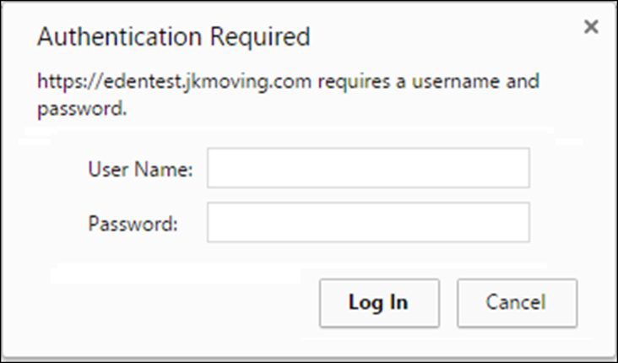

1. **This is an issue.**
   1. Put in a ticket with **Tech Support**, as they will need to take the necessary steps to fix this.
      1. Be sure to tell them exactly what steps you took and what the results were.
      2. Including screen shots is very helpful.

## The Welcome Page (Highlighted Options)

The Welcome Page, “Explore CRM”, will appear once you successfully enter the JIM application. This page gives you a brief summary of a few of the main page navigation options.

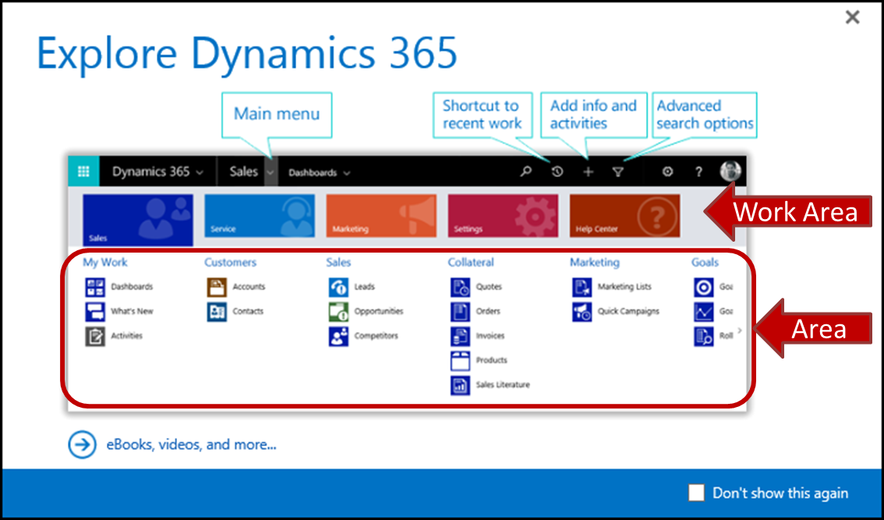

### Show/Don’t Show the Welcome Page

In the bottom right of the welcome page is a check box labeled “Don’t show this again”. With this you have the option to allow the Welcome Page to appear, or not appear, when logging in.

1. Navigate to the Welcome Page, if it isn’t already displayed.
   1. Select the “Settings” button. 
   2. The “Settings” dropdown menu will appear.
   3. Select the “See Welcome Page” option.

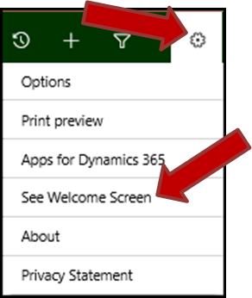

1. The Welcome Page will display.
   1. **Show Welcome Page** – Remove the check from the “Don’t show this again” checkbox.
   2. **Don’t show the Welcome Page** – Place a check in the “Don’t show this again” checkbox.
2. Close the Welcome Page, by selecting the X button in the upper right.

## The Menu

### View the Main menu

Selecting the down arrow button next to the current work area will present the Main menu. The Main menu displays the different Work Areas and Areas. What displays is based on your account settings.

**Actual Work Areas:**

* **Sales** – This lets you view invoices, dashboards, reports and etc.
* **Service** – The “Service” Work Area is used to view accounts, moves, activities, contacts, Crates, Pallets, Default Material Lists and etc.
* **Settings** – This lets you view Business, System, Process Center, North52 and etc.
* **CRM Charge** – Here you may view ePayments and System Alerts.
* **Help Center** – This takes you to the “CRM Help Center” (Dynamics 365). Here you may learn more about Help & Training, Setup & Administration and Developer Center.

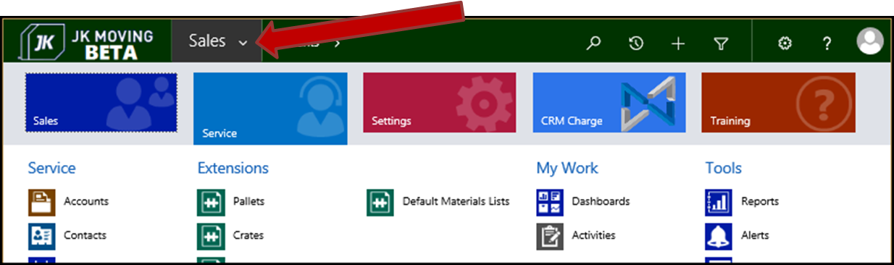

When the Work Area is selected, the Area options will display. Pictured below are the Areas may be available when the “Service” Work Area is selected.

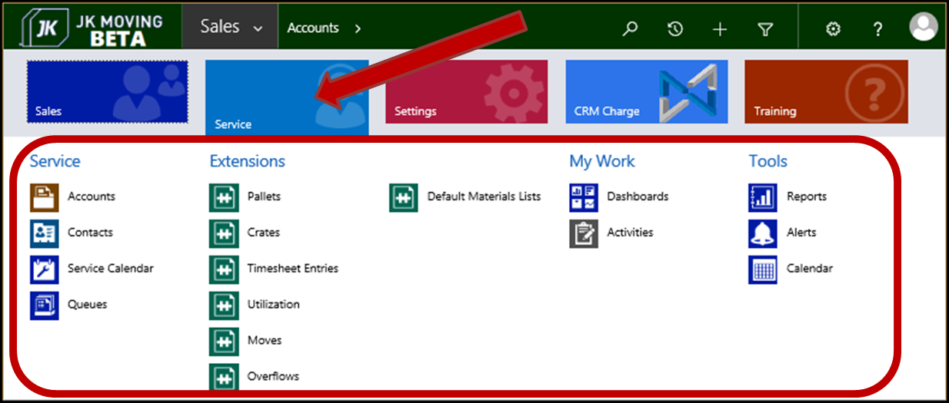

### Recently Viewed Items

Selecting this button will take you back to recent work and pinned favorites. 

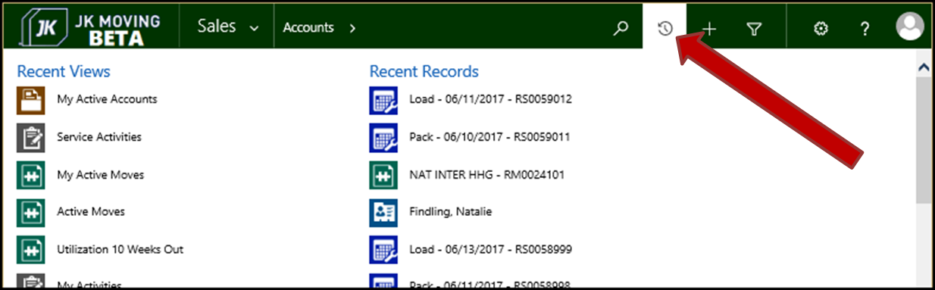

### Search CRM data

The search feature allows you to search JIM by customer first name, last name, phone number, customer number and etc. Selecting the magnifying glass button allows you to perform a search.  Just enter the search criteria into the field displayed and select the Enter key. The Search will be performed and the results will display on the “Search” page.

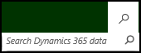

You may also apply a Filter to your search.

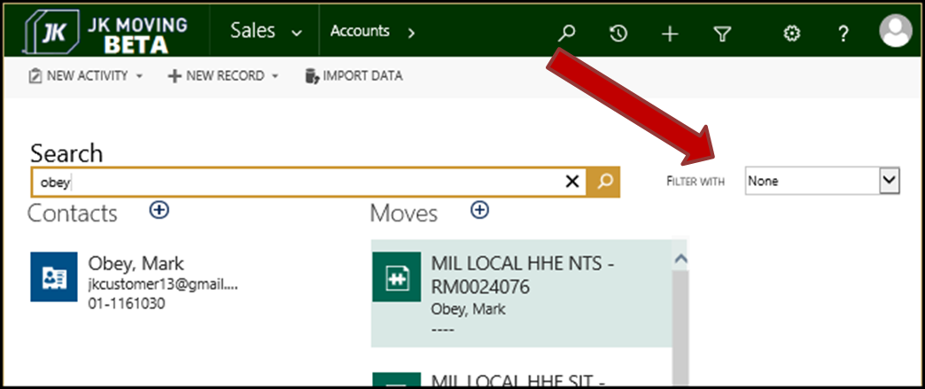

### Settings

Settings may be reached by selecting the grommet button.  Once selected, the “Settings” dropdown menu will appear.

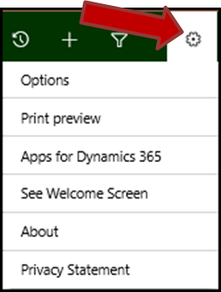

### Navigation Path

As you navigate deeper down a chosen path, the Navigation Bar displays that path next to the “Main” menu button.

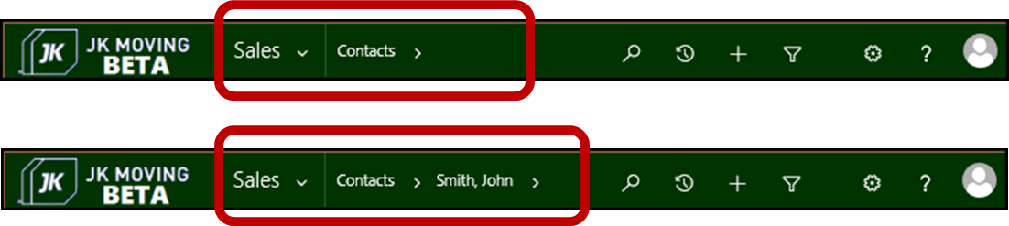

# Search & Filter Record Views

## Select a View Page

1. If not already there, navigate to the desired default View page.
2. The default View page will be displayed.
3. Select the down arrow next to the View page name.
   1. The dropdown list of available Views will display.

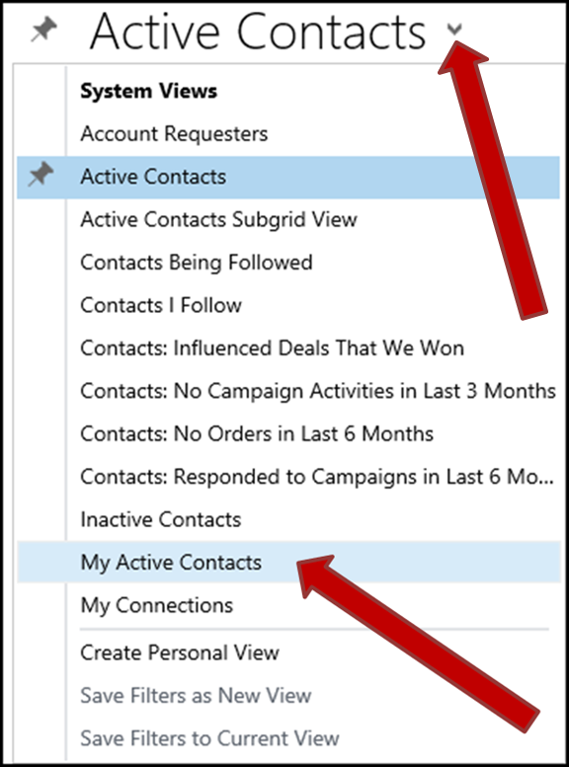

1. Select the desired View.
2. The selected View page will now be displayed.

## Search Records

### Information on Performing a Search

* The searches are not case sensitive.
* Searches are performed on all Active records. Inactive records are not searched.
* The Search may be performed on one or more data fields (columns) in the View’s records. i.e. Not all data fields are searched. (For example: Name, Phone, Email, Customer Number, City and/or etc.)
* When conducting the search, you must enter data starting with the first characters in the field. The search is performing a “Begins With” type operation. For example: When searching for the last name of “Johnson”, you may enter “Joh”, “Johns” and etc. You may not enter “ohns”, “nson” and etc.
* The wild card is an asterisk ( * ). In the previous example of looking for the name of “Johnson”, you may enter “*ohns” or “*nson” to conduct the search.

### Perform a Regular Search

1. Perform the steps in section Perform a Search.
   1. Use just the beginning characters for the search text.
      1. In our example, use “aar” in the search field.

### Perform a Wild Card * Search

1. Perform the steps in section Perform a Search.
   1. Use the wild card asterisk (*) in the first position of the search text.
      1. In our example, use “*aar” in the search field.

### Perform a Search

In the below steps we are using Contacts as the example when presenting the search capabilities. These steps pertain to all View pages with Search capabilities.

1. Select a View Page, to locate the desired View page be searched.
2. The View page will be displayed.
3. Locate the Search field.
   1. It’s in the upper right area of the page.
4. Enter the data to be searched.
   1. In the regular search example we will enter “aar”.
   2. In the Wild Card search example we will enter “*aar”.
5. Select the magnifying glass icon to perform the search.

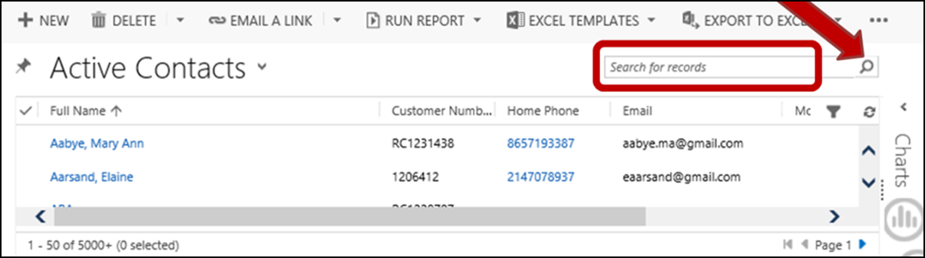

#### Regular Search

1. The records found using the **regular search** data “aar” will display in the “Search Results” page.
   1. A count of the found records displays in the lower left corner of the “Search Results” window.
   2. Notice that records were found with emails that start with “aar”, but the Names don’t.
   3. Notice that records were found with Full Names that start with “aar”.

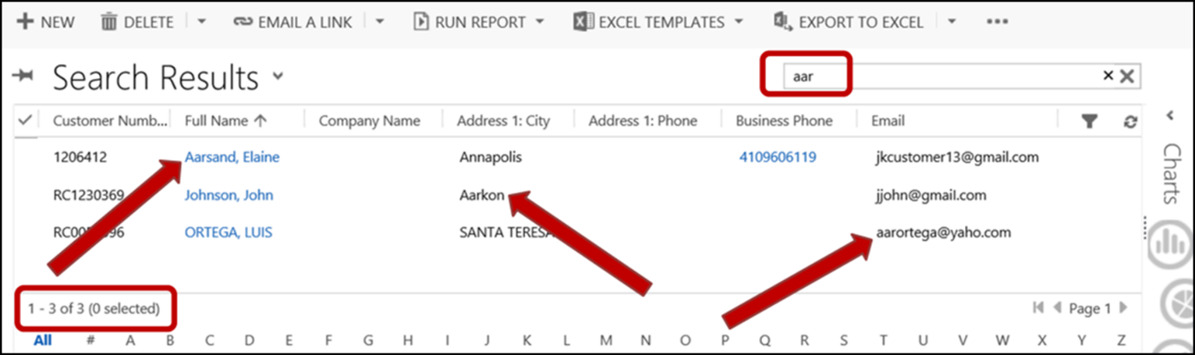

#### Wild Card Search

1. The records found using the **wild card** **search** data “*aar” will display in the “Search Results” page.
   1. A count of the found records displays in the lower left corner of the “Search Results” window. Notice that more records were found using the wild card.
   2. Notice that records were found with emails that start with “aar”.
   3. Notice that records were found with the string “aar” embedded within the field. In the examples there is a first name of “Aaron” found and a last name with “aar” in the middle of it found.
   4. Notice that records were found with Full Names that start with “aar”.

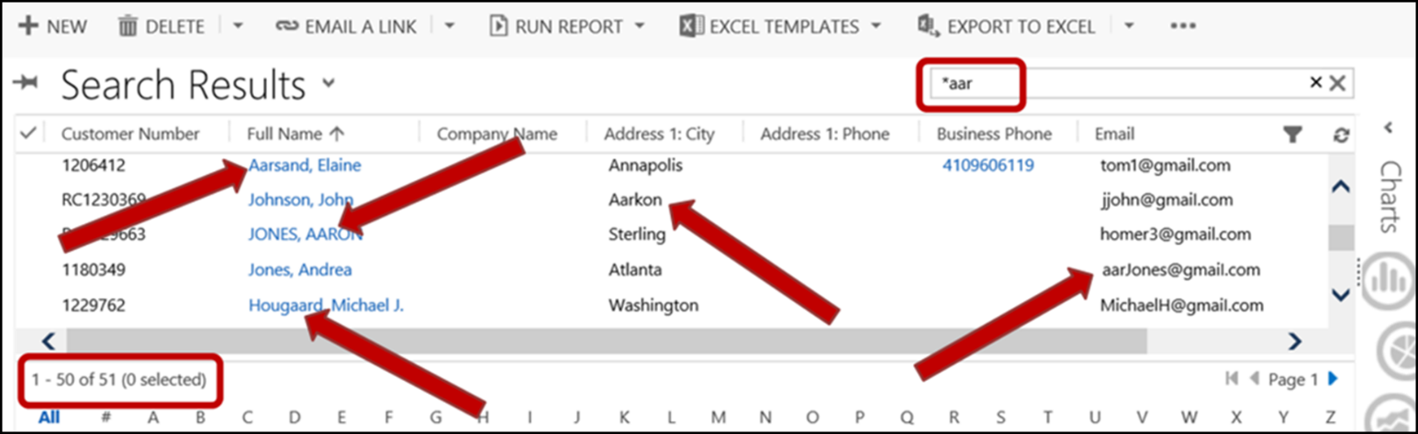

### Clear Search Field

You may clear just the text from the Search field.

1. Select the small “x” towards the right of the Search field.
2. The Search field will clear and be blank.
3. The “Search Results” page will continue to display the previous search.
   1. **Note:** Entering new search criteria at this point will perform the search on all active records. i.e. It doesn’t build on the last search.

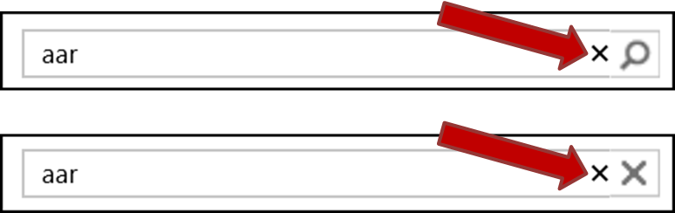

### Clear Search Results

You may clear the search results and return to the original View.

1. Select the large “X” on the far right of the Search field.
2. The last selected View page will display.
   1. The display will be at the top of the records.

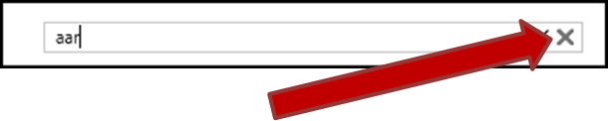

## Sort Records

Sorting of records may be performed on any column that is displayed.

* Only one column at a time may be sorted.
  + Each new sort ends the previous sort
* The sort indicator is an arrow, it appears directly to the right of the sorted column heading text.
  +  Indicates **Ascending** **sort** order.
  +  Indicates **Descending** **sort** order.

**Sort a Column**

1. Select a View Page, to locate the desired View page be sorted.
2. The View page will be displayed.
3. Locate the column to be sorted.
4. Click once on the column heading.
5. The records are now sorted in ascending order.

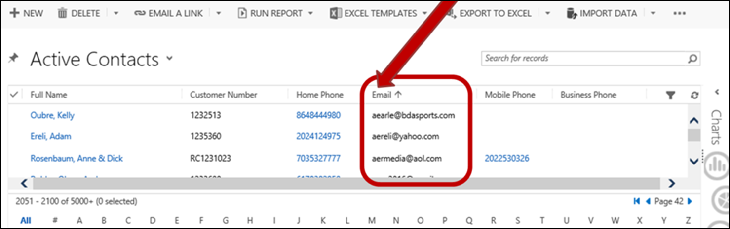

1. Click a second time on the column heading, to reverse the sort order.

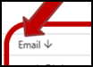

## Filter Records

Filters are used to locate a specific record or a group of records within a View page.

In the below sections we are using Contacts as the example when presenting the filter capabilities. These steps pertain to all View pages with filtering capabilities.

* Once turned on, in an Area, the Filter remains on for all views until it is turned off or you navigate to a different Area.
  + An Area may be Contacts, Moves, Activities, etc.
* Upon entering an Area, the Filter default is off.
* The filters are not case sensitive.
* You can filter on one or more columns.

### Turn On/Off Filtering

1. Select the “Filter” icon, to toggle on or off.
   1. On – The Filter icon is medium blue with a light blue background. 
      1. When the Filter is on the display columns will have small triangular down arrows  on the far right side of each filtered column heading.
      2. Note: Some columns may not be filtered.
   2. Off – The Filter icon is grey with a white background. 
      1. When the Filter is off, there will be no down arrows displayed.

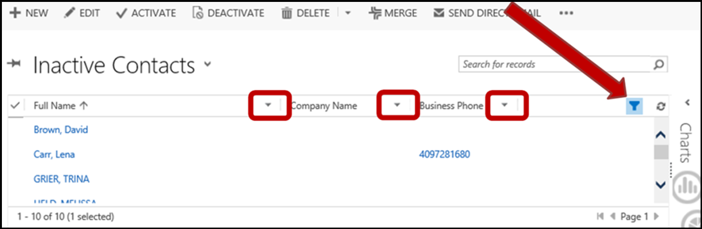

### Perform a Filter

1. Select a View Page, to locate the desired View page be filtered.
2. The View page will be displayed.
3. Turn on the Filter.
   1. Select the Filter button in the top right of the Contacts view table grid. 
   2. **Note: F**iltered columns will have a filter indicator to the far right of their column heading. 
4. Select the filter indicator for the column you want to filter. 
   1. Pictured here, we are filtering on the “Full Name” field.

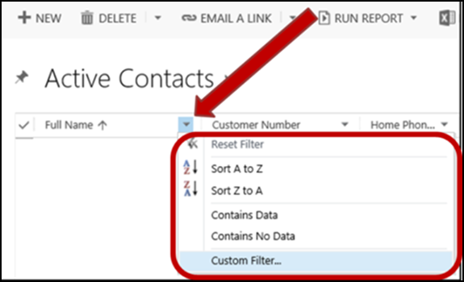

1. The Filter menu will display.
   1. Filter options:
      1. **Reset Filter** – Selecting this will cancel any existing filters placed on this column.
      2. **Sort A to Z** – Sort the records in descending order, based on values in this column.
      3. **Sort Z to A** – Sort the records in ascending order, based on values in this column.
      4. **Contains Data** – Filter for only records with data in this column.
      5. **Contains No Data** – Filter for only records without any data in this column.
      6. **Custom Filter**… – Here you may customize your filtering criteria.
      7. There may be other options. Explore them to determine what they do, filtering doesn’t alter the data so exploration here is harmless.
2. Select the “Custom Filter…” option.
3. The “Custom Filters” window will display.
   1. Select a conditional operator, by selecting the down arrow next to the “Select Operator” field.

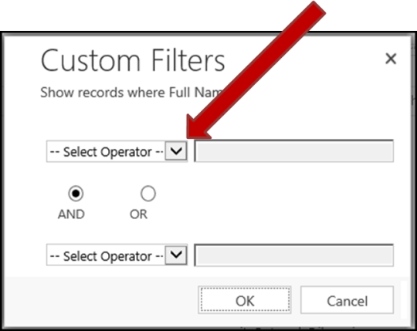

* + 1. The Operator menu will display.

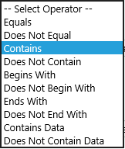

* + 1. Select the “Contains” Operator.
  1. Enter a value into the field next to the selected operator.
     1. Here we enter “arr”, to retrieve only records with this character string in the Full Name field.
  2. Select the logical operator.
     1. AND
     2. OR
  3. Select the second conditional operator.
     1. Select the “Does Not Begin With” operator.

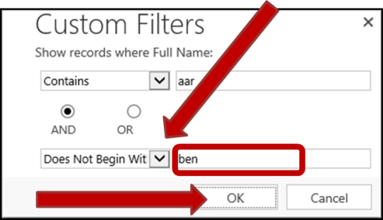

* 1. Enter a value into the field next to the second selected operator.
     1. Here we enter “ben”, to retrieve only records whose Full Name field begins with this string.
  2. Select the “OK” button, to commit the filter customization.

1. The column filter selector changes to a filter symbol. 
2. The only the records that meet the filter conditions will display.
   1. **Summary for the Filter we just built**:
      1. This filter will now retrieve only records with a Full Name that contains the letter string “aar” somewhere within the field AND the Full Name does not begin with the letter string “ben”.

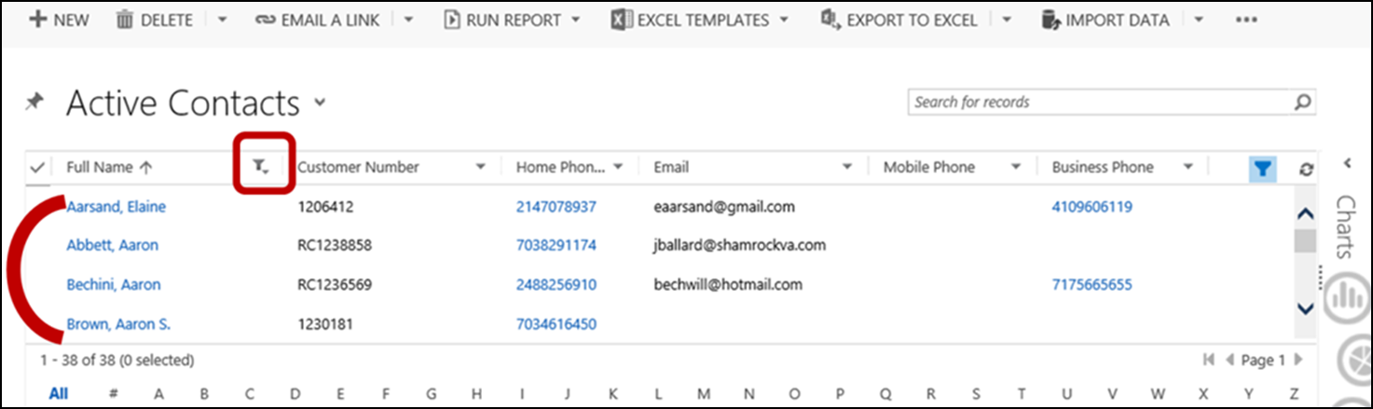

### Reset Entire Filter

1. Turn off the Filter.
   1. See section Turn On/Off Filtering.
2. Turn on the Filter.
3. All column Filters are now reset.

# Printing Reports

There are various pages around JIM where reports are available. These reports may be viewed and printed.

## Print Button

1. Navigate to the “Report Viewer” window.
2. The “Print” button  should be visible in the “Report Viewer” window.
   1. Pictured here is the “Report Viewer” window accessed through Internet Explorer.

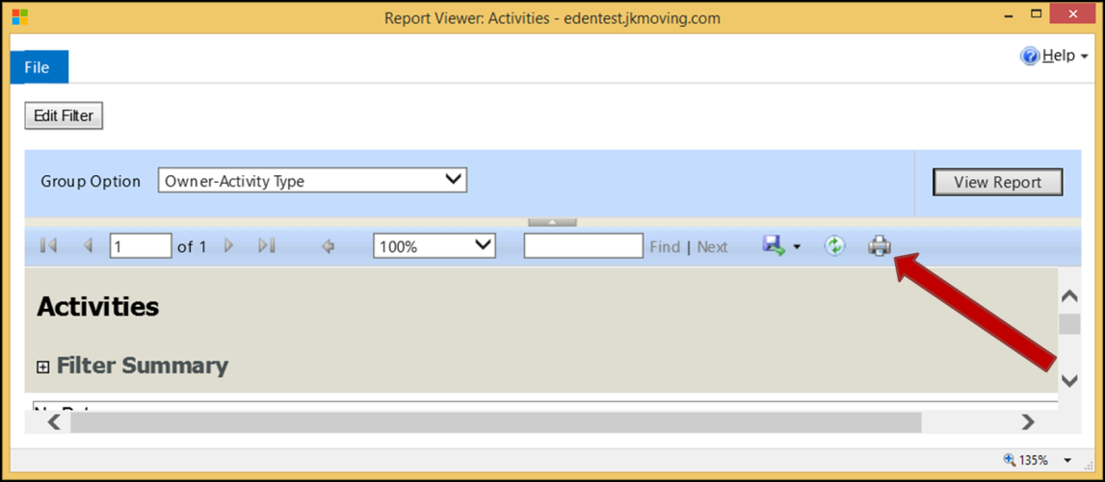

### No Print Button

1. Some browsers may not display the “Print” button.
   1. Pictured here is the “Report Viewer” window with the “Print” button missing.

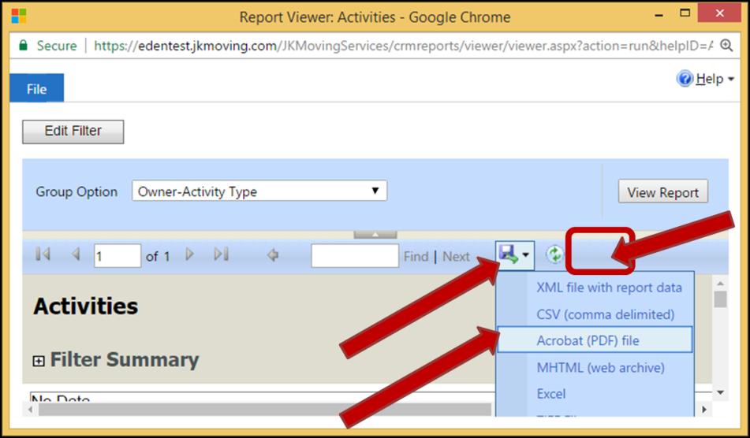

1. If this is the case, you may save the Report as a PDF file.
2. Perform the printing of the Report from the saved PDF file.

# Navigation of a Record View

There are various Views for records. These record table Views may be for Contacts, Moves, within Dashboards and etc. This section shows some of the options for navigating through these Views.

## Resize a Column

1. At this point you should already be on a View page with the desired records displayed
2. Place the cursor so that it hovers over the column divider to the right of the column to be resized.
   1. The cursor will change to an expansion arrow. 
   2. **Note:** The column to the left of the expansion arrow is the one that will be resized.
3. Click with the left mouse button and hold.
4. Drag the column edge in the desired direction.
   1. **Left** – Dragging the expansion arrow to the left will make the displayed column smaller/narrower.
   2. **Right** – Dragging the expansion arrow to the right will make the displayed column larger/wider.
5. Let go of the mouse button.
   1. Here we will drag the “Full Name” column to the left, to reduce the “Full Name” column.



1. Repeat the click and drag steps to expand the “Address: City” field.
2. Both columns are now resized.



## Select Record(s)

Records may be selected in order to perform some action, such as Activate, Delete, Edit and etc. One or more records may be selected for action.

1. At this point you should already be on a View page with the desired records displayed
2. Click once on one of the desired records.
3. Hold the “Ctrl” key while clicking on each additional record to be selected.
   1. **Note:** As each record is selected, a check mark appears in the first column.

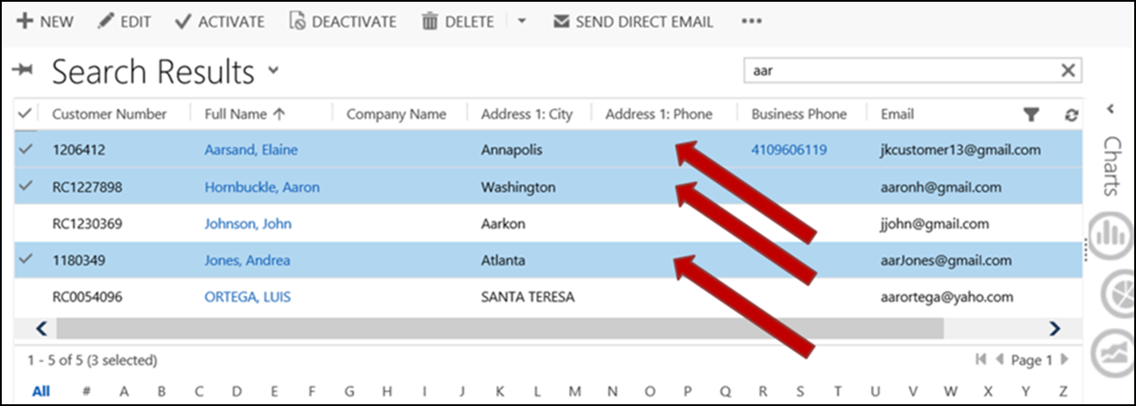

1. The records are now ready for some group action.

## Page Number/Navigation

The “Page” number is displayed in the lower right corner of the View display.



1. Use the navigation buttons to move to another page.
   1.  Previous Page – takes you to the page just before the one you are on.
   2.  Next Page – takes you to the page immediately after the one you are on.
   3.  First Page – takes you to Page 1.
   4. There is no Last Page button.

## Record Count

The Record Count is displayed in the lower left corner of the View display.



* The first set of numbers is which group of records is displayed. Pictured here it shows that records 1 through 50 are displayed on the page and may be scrolled through.
* The next number, after the word ‘of’ is the total number of records available. Here it shows that there are over 5,000 records. 5,000 is the count limit and the + indicates there are more than that number of records available.
* The number between the parentheses indicates the total number of records selected. See section [Select Record(s)](#_Selecting_Record(s)) for more information.
  + Selection of records is limited to just the group of records displayed. If you navigate to another page, your selection is abandoned.

## Display by Alphabet

Expand the window left to right, if you don’t see the Alphabet selections available at the bottom of the window.

1. At this point you should already be on a View page with the desired records displayed
2. At the bottom of the View page are viewing buttons. All, # and the alphabet.
   1. **All** (default) – Selecting this will retrieve all records that the View page may access.
   2. **#** - Selecting this will retrieve only records whose primary field value begins with a number.
   3. **Alphabet** – Selecting a letter will retrieve only those records whose primary field value begins with that letter.

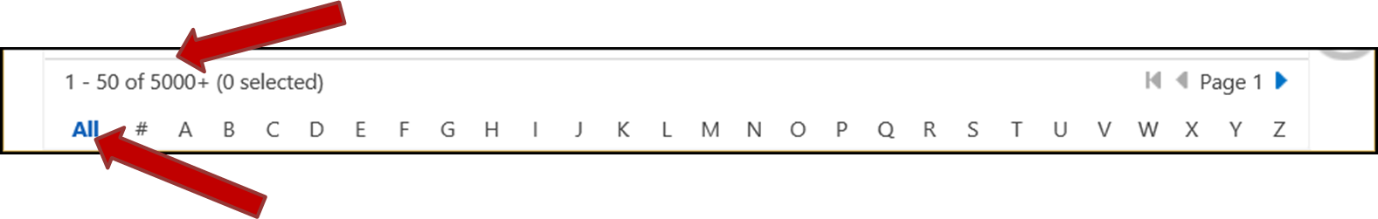

1. With “All” selected, for this example, notice that the total records is “5000+” for this View page.
   1. This indicates that there are over 5,000 records that this View page may access.
2. Select a letter.
   1. With “A” selected, notice that the total records is now “1168” for this View page.
      1. This indicates that there are 1,168 total records whose primary field value begins with the letter “A”.

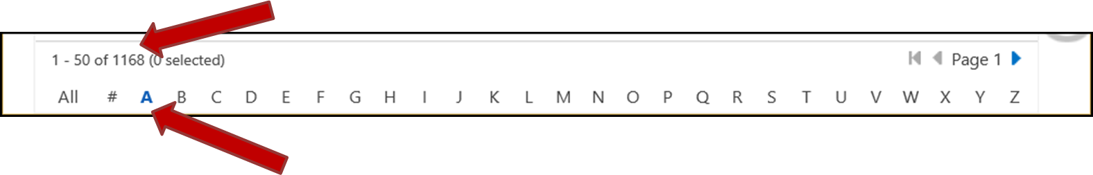

## Set Default View on a Page

The default view may be reset on many pages in JIM. For example the following pages may have their view reset: Contacts, Accounts, Queues, Moves, Activities and more pages.

1. Select a View Page, to locate the desired View page be set as default.
2. The View page will be displayed.
3. Select the pin icon that is just to the left of the View’s title.
   1.  – The view is not the default, when the pin is horizontal.
   2. – The view is the default, when the pin is at an angle.
4. If you set the pin icon at an angle, this is now the new default View for this page.

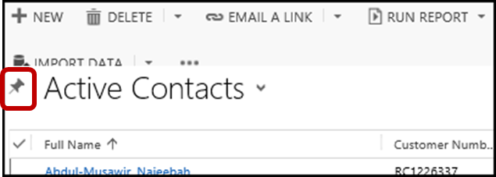

# Dashboards

Dashboards can be created to be used by everyone on the system or individuals may create their own dashboards. System dashboards can be seen by selecting “Service” from the Main menu and then clicking on the “Dashboards” icon.

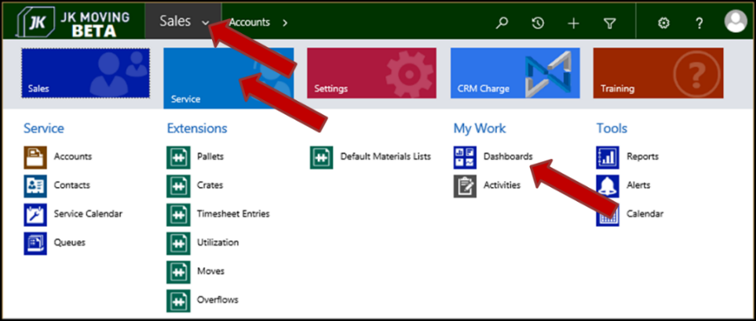

## Navigate to Dashboards

1. Select the “Service” Work Area, from the Main menu.
2. Locate and select the “Dashboards” Area under the “My Work” column.
3. The default Dashboard View page will appear.

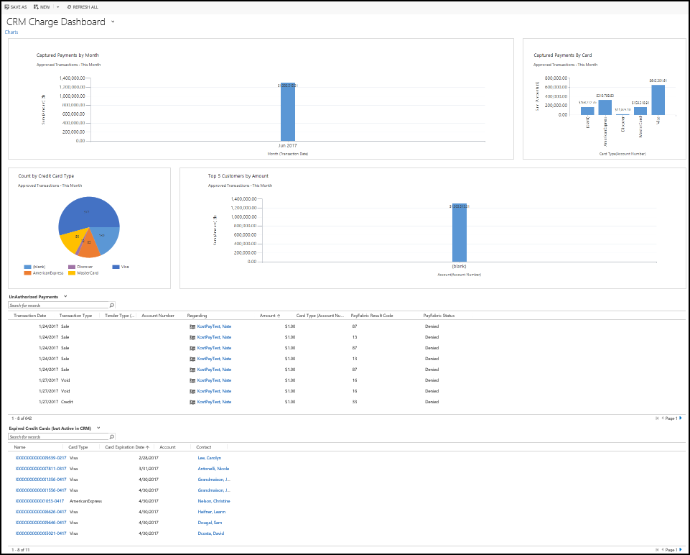

## All Views Available for Dashboards

1. Select the down arrow next to the current dashboard title.
2. The current list of System and Personal Dashboards will display.

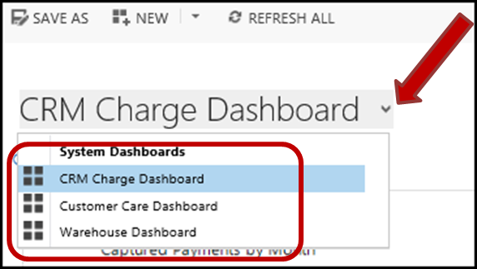

## Customer Care System View Dashboard

The Customer Care dashboard is personalized for each user and showcases the services that are taking place on the current day and the next day. It will also highlight list of pending moves owned by the current user. In addition, it also displays the phone call activities for Local, Intrastate and Interstate services.

The Dashboard will change on a daily basis based on the moves and services created by the current user.

1. Navigate to Dashboards.
2. View Dashboards List.
3. Select the “Customer Care Dashboard”.
4. The “Customer Care Dashboard” will display.
5. The “Customer Care Dashboard” is split into 4 quadrants.
   1. Today’s Service Activities
      1. This quadrant will show all the services planned for the current day.
   2. Tomorrow’s Service Activities
      1. This quadrant will show all the services planned for the next day.
   3. New Moves
      1. This quadrant will show all the pending moves created by the current user.
   4. My Activities
      1. This quadrant will show the Activities that belong to you.

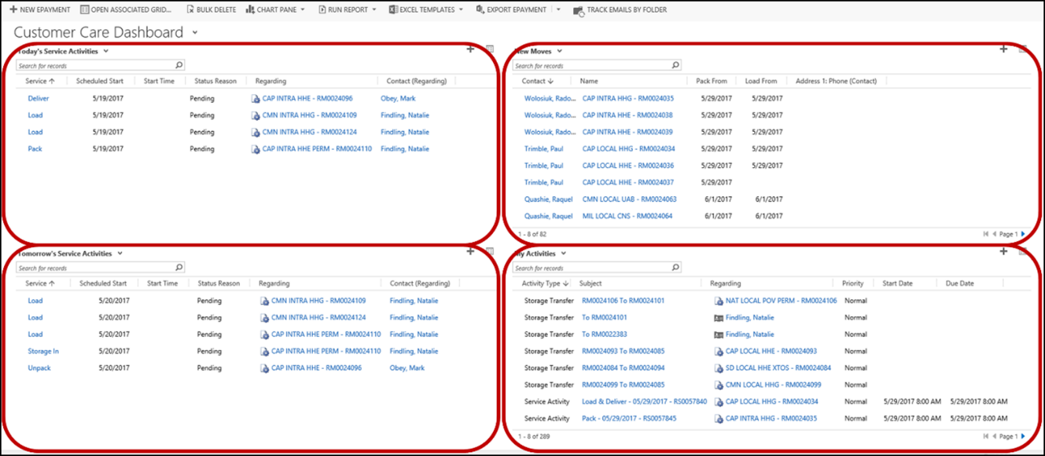

## Dashboard Quadrant - Capabilities

### Add New Record to a Dashboard

In the upper right of each quadrant is a + button.  This button is used to add new records to the Dashboard component displayed in that quadrant. For example, if the records displayed are Contacts, you would use this button to create a new Contact.

### Alternate View of Records

In the upper right of each quadrant is a button  to see the records in an alternate view. This alternate view is in a separate window and gives the User more capabilities for dealing with the records. (You have a wider view of the records. The ability to filter, delete, reports and etc.)

## My Dashboards

The User may design and create private dashboards.

### Create a Dashboard

1. Navigate to Dashboards.
2. Select the “New” create a dashboard button. 
3. The “Choose Layout” window will open.
   1. Choose which layout you want for the dashboard.
   2. Select the “Create” button

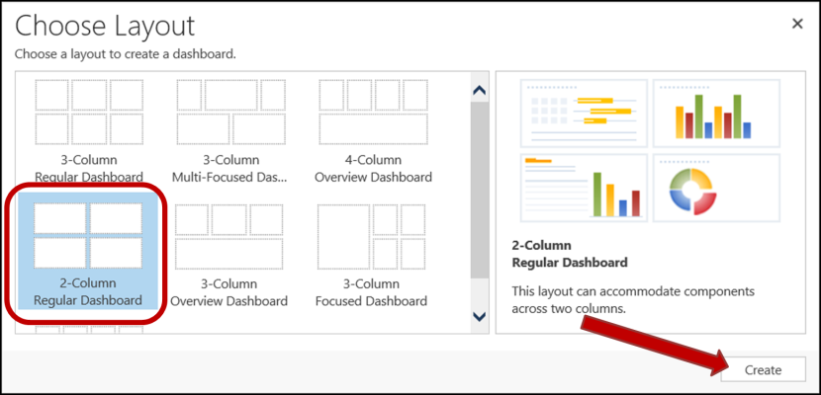

1. The blank dashboard design page will display.
2. Setup a quadrant.
   1. Enter a “Name” for the new dashboard. This is a mandatory data field.
   2. Select a quadrant to be designed.
      1. The selected quadrant will have a solid line around it.
      2. The unselected quadrants will have dashed lines around them.

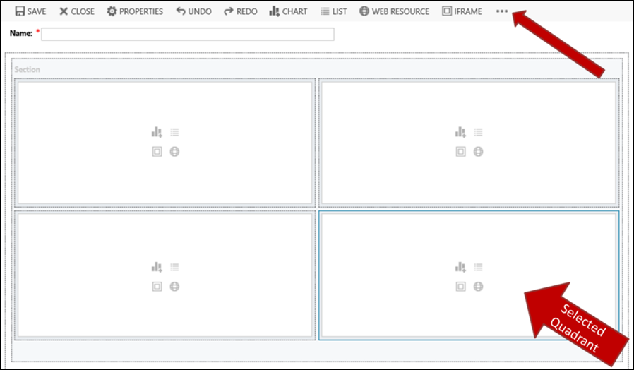

* 1. Resize the display quadrant.
     1. Select the “More” button. 
     2. Select to increase or decrease the quadrant windows width or the height.

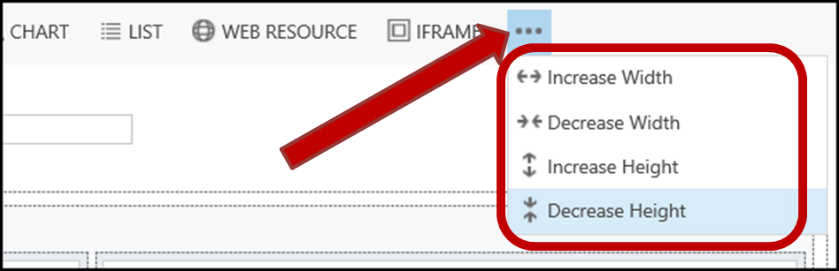

* 1. You may remove a quadrant, by selecting the quadrant and selecting the Delete keyboard key.
  2. Select what type of Component to place in the quadrant.
     1. This may be done from icons inside the middle of the quadrant.



* + 1. It may also be done from the menu bar near the top of the quadrant window, just above the “Name” field.

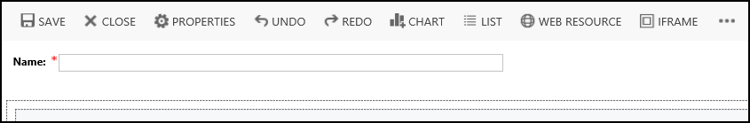

* + 1. Components:
       1.  Chart
       2.  List
       3.  Web Resource
       4.  Iframe
  1. The “Add Component” window will display.
     1. Enter appropriate information for the selected Component.
  2. If adding a Chart or List, select the “Add” button, to add the Component to the quadrant.
  3. If adding a Web Resource or Iframe, select the “Add” button, to add the Component to the quadrant.
  4. The dashboard design page will redisplay showing the newly designed quadrant.

1. Repeat the steps to setup each quadrant.
2. Save the new Dashboard, by selecting the “Save” button, on the menu bar. 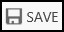

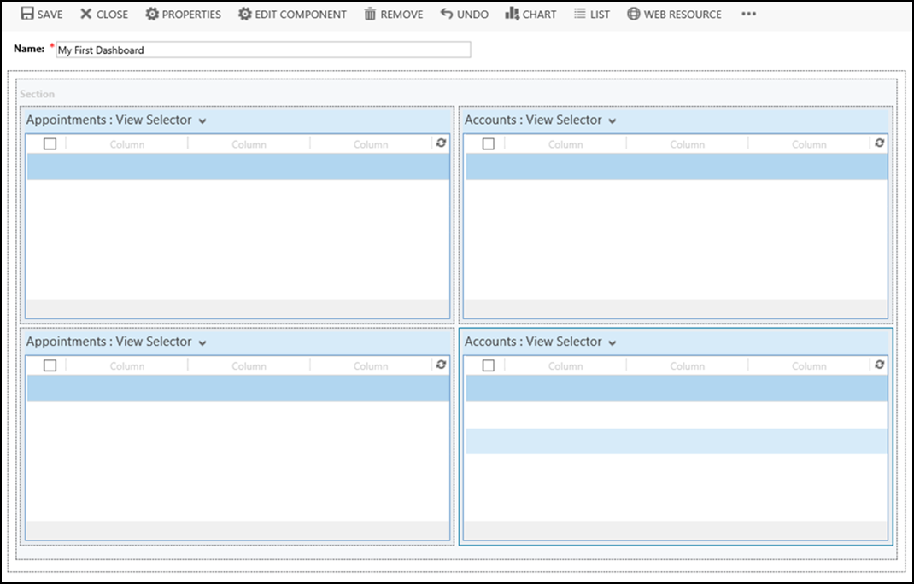

# Contacts

All Information pertaining to the customer is recorded and maintained in Contacts. Contacts can be created, edited, deleted, deactivated or activated as per business requirement.

## Navigate to Contacts

1. Access Contacts from the menu.
   1. Select the “Service” Work Area, from the Main menu.
   2. Locate and select the “Contacts” Area, found under the “Service” column.
   3. The default Contacts View page will appear.
2. Access Contacts from the Service Navigation Path.
   1. Select the down arrow next to the “Service” label on the Navigation Path.
   2. Locate and select the “Contacts” Area under the “Service” column.
   3. The default Contacts View page will appear.
3. The default Contacts page will appear.
   1. Initially, the default is the current user’s “My Active Contacts” view.

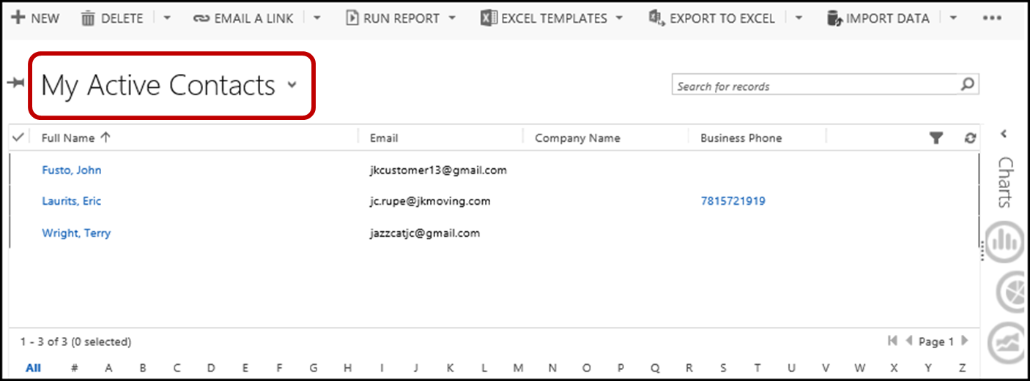

## All Views Available for Contacts

1. Select the down arrow to the right of the current Contacts view title.
2. The “System Views” will display below the title.
   1. The current View will be highlighted.

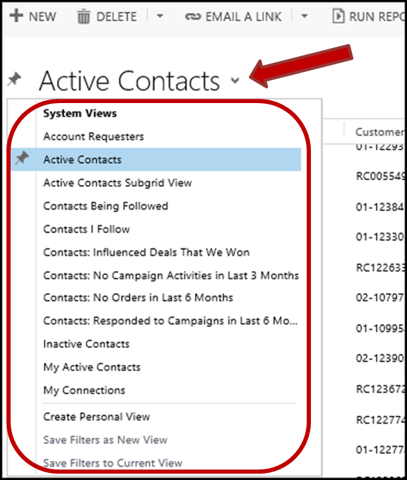

### Active Contacts View

1. Select the down arrow to the right of the current Contacts view title.
2. The “System Views” will display below the title.
3. Select the “Active Contacts” option.
4. The “Active Contacts” view will display.

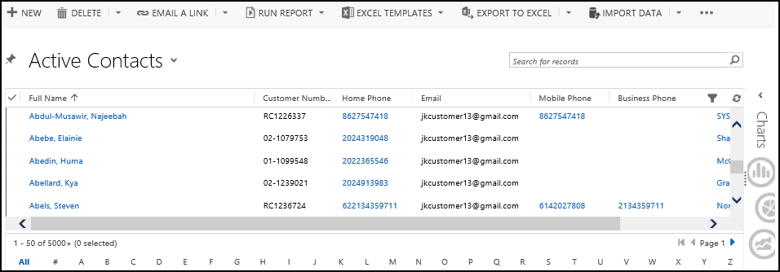

## Search for a Contact

1. The Contacts view should be displayed.
2. Perform a Search.
   1. Use the data in the search field that will help locate the desired Contact record(s).

## Sort Contact View Columns

1. The Contacts view should be displayed.
2. Sort Records on the desired column that will help locate the desired Contact record(s).

## Filter Contact View Columns

1. The Contacts view should be displayed.
2. Filter Records on the desired column(s) that will help locate the desired Contact record(s).

## Set Default Contacts View

1. Navigate to Contacts.
2. The default Contacts view will display.
3. Select a View Page, to locate the desired View page.
4. Set Default View on a Page.
5. The default View should now be set for the Contacts page.

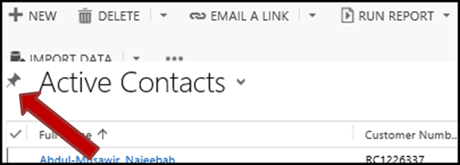

## Create a New Contact

1. Navigate to Contacts.
2. Select the “+ New” button, located in the upper left of the window.

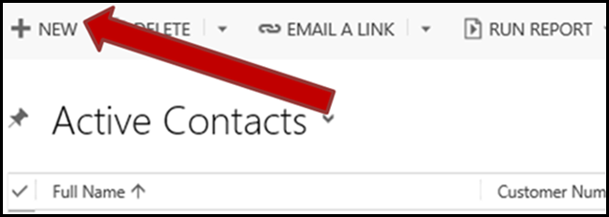

1. The “New Contact” page will display.
   1. Select the expansion arrow  to the left of the section(s) to be entered or edited.
      1. The sections are:
         1. General
         2. Moves
         3. Notes & Activities
         4. Storage

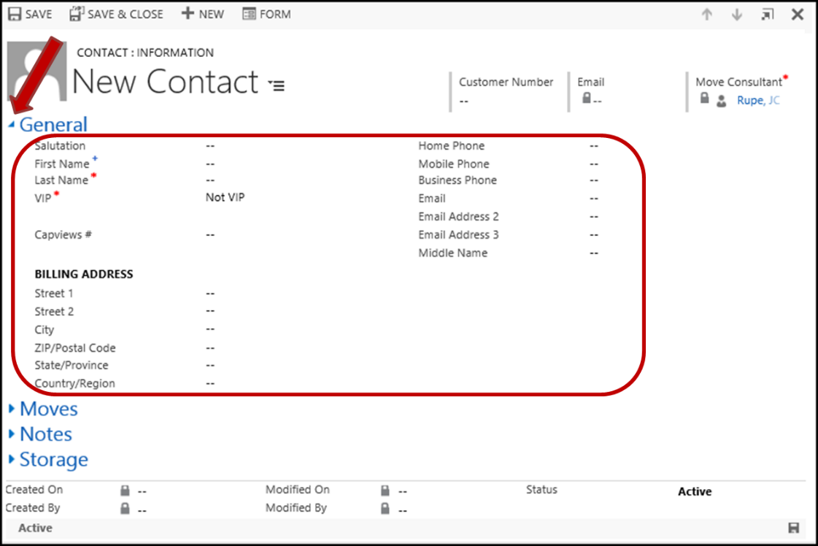

1. Enter appropriate data into the “New Service Activity” window.
   1. **General**
      1. Enter the contacts Salutation, First & Last Name, VIP info, Email and contact phone numbers (Home, Mobile and Business).
         1. Last Name and VIP info are mandatory fields.
   2. **Moves**
      1. Editing is not available until the new Contact record is saved.
   3. **Notes**
      1. Editing is not available until the new Contact record is saved.
   4. **Storage**
      1. Editing is not available until the new Contact record is saved.
2. Save the new Contact, by selecting the “Save” button.

## View and Edit a Contact

Only Active Contacts may be edited.

1. Navigate to Contacts.
2. Search for a Contact.
3. Double click on the desired Contact record.
   1. The “Contact” page will open.
4. Select the expansion arrow  to the left of the page section title(s) to be viewed or edited fields.
   1. Entries are now available for viewing or editing.
5. Select the “Save” button upon completion of editing.

## Deactivate a Contact

Deactivating a contact allows you to make a contact inactive, which means it cannot be edited or used. Deactivated contacts may be re activated should the need arise.

1. Navigate to Contacts.
2. Your default Contacts view page should be displayed.
3. Search for a Contact to be deactivated.
4. [Select Record(s)](#_Selecting_Record(s)) to be Deactivated.
5. Select the “Deactivate” button near the top left of the Contact view page.

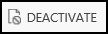

1. A confirmation will display.
   1. Select the “Deactivate” button.

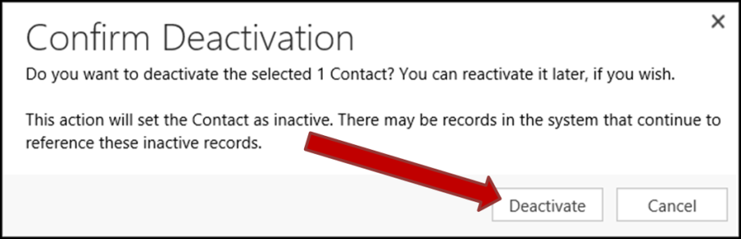

1. The Contact is now Deactivated.

## Activate a Contact

Activating a deactivated contact allows you to set a contact back to being Active, which means it may now be edited or used.

1. Navigate to Contacts.
2. Select a View Page, to select the System View for Inactive records.
3. Filter Records, to locate the desired Inactive Contact.
   1. **Note:** Using the Search feature will only locate Active Contacts.
4. [Select Record(s)](#_Selecting_Record(s)) to be Activated.
5. Select the “Activate” button near the top left of the Contact page.



1. A confirmation will display.
   1. Select the “Activate” button.

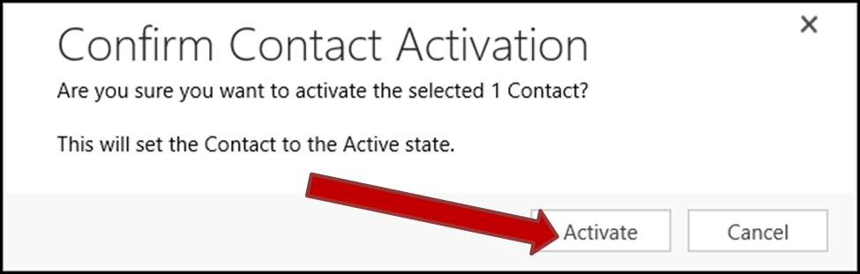

1. The Contact is now Activated.

## Contact/Customer Credit Card

See the “JIM – Charge on Credit Card” manual.

# Moves

## Navigate to Moves

1. Select the “Service” Work Area, from the Main menu.
2. Locate and select the “Moves” Area under the “Extensions” column.

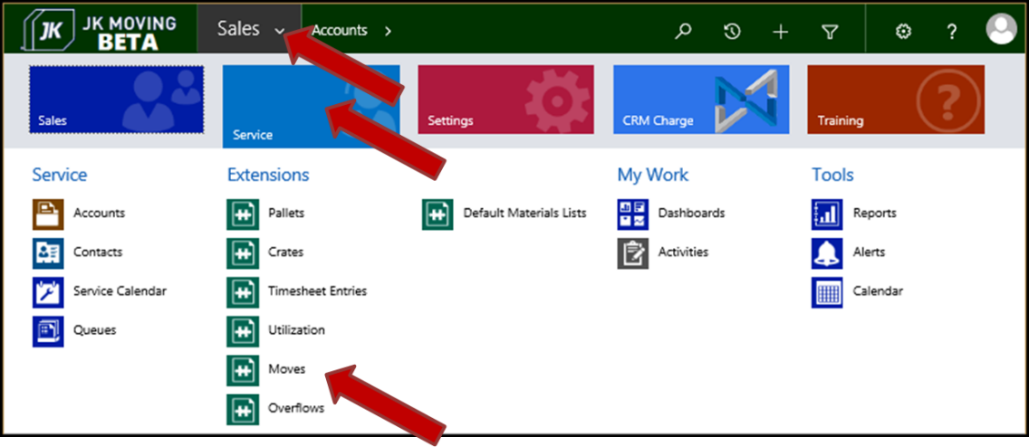

1. The default Moves View page will appear.

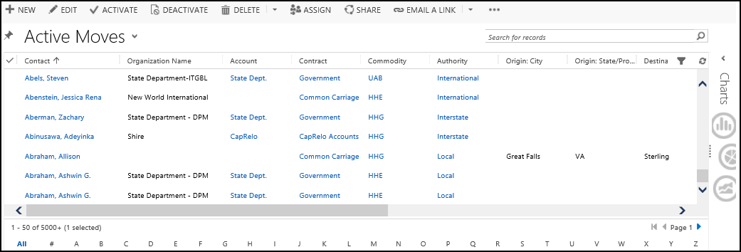

## All Views Available for Moves

1. Select the down arrow to the right of the current Moves View title.
2. The available Views, including the “System Views”, will display below the title.

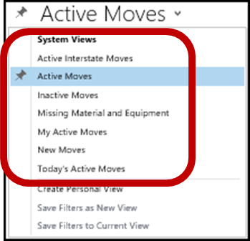

1. There are currently 7 possible “System Views”.
   1. **Active Interstate Moves** – This view displays all the active Interstate Moves.
      1. Columns displayed in the View are:
         1. **Name** – The Move name.
         2. **Created On** – The date the Move was created.
   2. **Active Moves** – This View displays all Moves whose Status is set to Active.
      1. Columns displayed in the View are:
         1. **Contact**
         2. **Organization Name**
         3. **Account**
         4. **Contract**
         5. **Commodity**
         6. **Authority**
         7. **Origin: City**
         8. **Origin: State/Province**
         9. **Destination: City**
         10. **Destination: State/Province**
         11. **Pack From**
         12. **Load From**
         13. **Delivery From**
         14. **Created On**
         15. **Created By**
         16. **Move Coordinator**
   3. **Inactive Moves** – This View displays all Moves whose Status is set to Inactive.
      1. Columns displayed in the View are:
         1. **Name** – The Move Name.
         2. **Created On**
   4. **Missing Material and Equipment** – This View displays all Moves that are missing material or equipment assignments.
      1. Columns displayed in the View are:
         1. **Authority**
         2. **Move Consultant**
         3. **Move Number**
         4. **First Name (Contact)**
         5. **Last Name (Contact)**
         6. **Organization Name**
   5. **My Active Moves** – Displays all Active Moves that are assigned to you as Coordinator.
      1. Columns displayed in the View are:
         1. **Contact**
         2. **Organization Name**
         3. **Account**
         4. **Contract**
         5. **Commodity**
         6. **Authority**
         7. **Move Number**
         8. **Origin: City**
         9. **Origin: State/Province**
         10. **Destination: City**
         11. **Destination: State/Province**
         12. **Pack From**
         13. **Load From**
         14. **Delivery From**
   6. **Today’s Active Moves** – Active Moves that are created today.
      1. Columns displayed in the View are:
         1. **Contact**
         2. **Organization Name**
         3. **Account**
         4. **Contract**
         5. **Commodity**
         6. **Authority**
         7. **Origin: City**
         8. **Origin: State/Province**
         9. **Destination: City**
         10. **Destination: State/Province**
         11. **Pack From**
         12. **Load From**
         13. **Delivery From**
   7. **New Moves** – This view is not currently active and may not show up in the list.
      1. Columns displayed in the View are:
         1. **Contact**
         2. **Name**
         3. **Pack From**
         4. **Load From**
         5. **Address 1: Phone (Contact)**

## The Move: Information Page

### What You First See

1. The “Move: Information” page will be displayed. This is the Move form.
   1. The “General” section is the top section and it’s expanded by default.

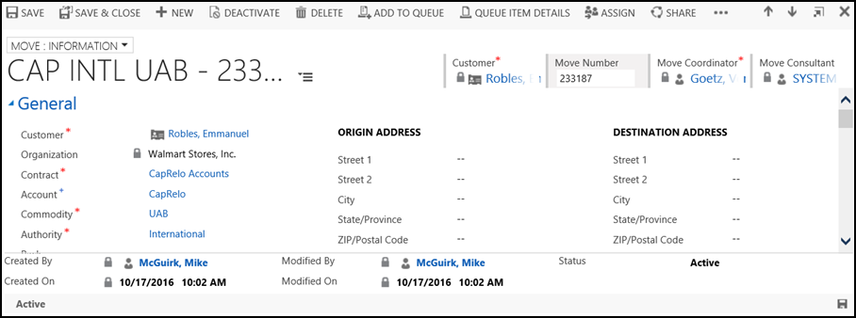

### See the Sections of the Move Form

The Move form is divided into sections necessary to properly complete the move information. The information is necessary for the successful communication of the move to entities needing to service the move.

1. Select the down arrow to the right of the current Moves view title.
2. The list of sections will display.
   1. Selecting a section will open (un-collapse) that section and take you to it on the page.

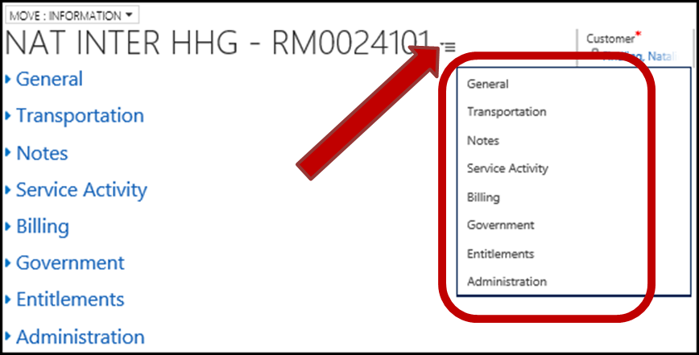

1. There are 8 sections to the Move information page.
   1. General section
   2. Transportation section
   3. Notes section
   4. Service Activities section
   5. Billing section
   6. Government section
   7. Entitlements section
   8. Administration section

### General section

1. The “General” section contains general information about the Move. Dates and Times, Origin and Destination information, Origin and Destination obstacles, Valuation and SIT.

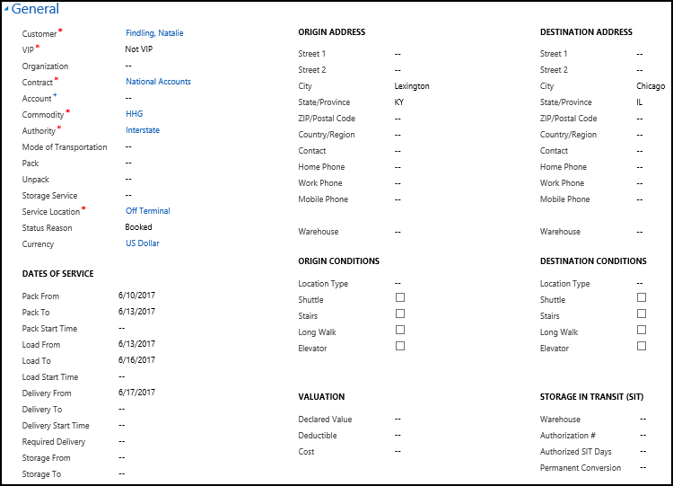

1. Required fields:
   1. **Customer**
   2. **VIP** flag.
      1. Options are:
         1. VIP
         2. Not VIP
   3. **Contract**
   4. **Commodity**
   5. **Authority**
      1. Options are:
         1. Local
         2. Intrastate
         3. Interstate
         4. International
   6. **Service Location**
      1. Options are:
         1. JK Virginia
         2. JK Maryland
         3. Off Terminal
2. Business Recommended fields:
   1. **Account**
3. Optional fields:
   1. **Organization**
   2. **Mode of Transportation**
   3. **Pack**
      1. Options are:
         1. *blank*
         2. Full
         3. Partial
   4. **Unpack**
      1. Options are:
         1. *blank*
         2. Full
         3. Partial
         4. Mattress Only
   5. **Storage Service**
   6. **Status Reason**
      1. Options are:
         1. Pending
         2. Booked
   7. **Currency**
   8. Dates of Service subsection
      1. **Pack From** date
      2. **Pack To** date
      3. **Pack Start Time**
      4. **Load From** date
      5. **Load To** date
      6. **Load Start Time**
      7. **Delivery From** date
      8. **Delivery To** date
      9. **Delivery Start Time**
      10. **Required Delivery** date
      11. **Storage From** date
      12. **Storage To** date
   9. Origin Address subsection
      1. **Street 1**
      2. **Street 2**
      3. **City**
      4. **State/Province**
      5. **ZIP/Postal Code**
      6. **Country/Region**
      7. **Contact**
      8. **Home Phone**
      9. **Work Phone**
      10. **Mobile Phone**
      11. **Warehouse**
   10. Destination Address subsection
       1. Uses the same named fields as listed in Origin Address, above.
   11. Origin Conditions subsection
       1. **Location Type**
          1. Options are:
             1. *blank*
             2. House
             3. Townhouse
             4. Apartment
             5. Storage Unit
             6. Warehouse
       2. **Shuttle** check box
       3. **Stairs** check box
       4. **Long Walk** check box
       5. **Elevator** check box
   12. Destination Conditions subsection
       1. Uses the same named fields as listed in Origin Conditions, above.
   13. Valuation subsection
       1. **Declared Value**
       2. **Deductible**
       3. **Cost**
   14. Storage In Transit (SIT) subsection
       1. **Warehouse**
       2. **Authorization #**
       3. **Authorized SIT Days**
       4. **Permanent Conversation**

### Transportation section

1. The “Transportation” section contains information about transportation costs, mileage, weight and survey.

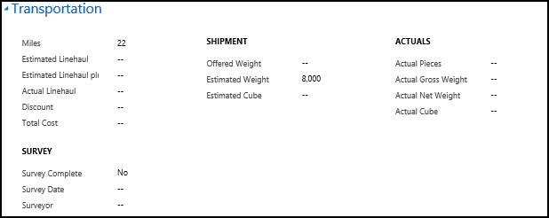

1. Optional fields.
   1. **Miles** – The distance in miles between the Origin and the Destination.
   2. **Estimated Linehaul**
   3. **Estimated Linehaul** **plus Flat Rate**
   4. **Actual Linehaul**
   5. **Discount**
   6. **Total Cost**
   7. Shipment subsection
      1. **Offered Weight**
      2. **Estimated Weight**
      3. **Estimated Cube**
   8. Actuals subsection
      1. **Actual Pieces**
      2. **Actual Gross Weight**
      3. **Actual Net Weight**
      4. **Actual Cube**
   9. Survey subsection
      1. **Survey Complete** Yes/No toggle
      2. **Survey Date**
      3. **Surveyor**

### Notes section

1. The “Notes” section is used for entering special information, instructions and/or notes that aren’t covered elsewhere.

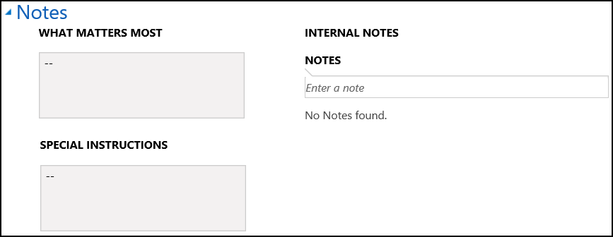

1. Optional fields:
   1. **What Matters Most**
   2. **Special Instructions**
   3. Internal Notes
      1. **Notes**
      2. All previously entered Notes are listed below the “Notes” entry field.
         1. Information displayed for each Note is:
            1. Actual Note text.
            2. Who entered the Note.
            3. Date/Time when the Note was entered.

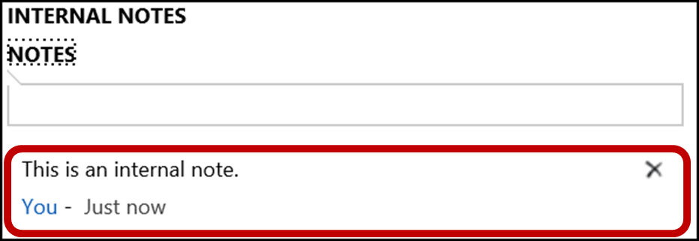

### Service Activities section

1. The “Service Activities” section consists of a table displaying all the Service Activities associated with the Move. From here you may add or remove a Service Activity.

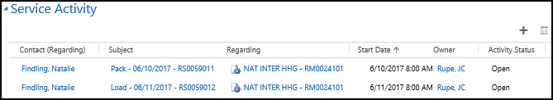

1. Displayed fields:
   1. **Contact (Regarding)**
   2. **Subject**
   3. **Regarding**
   4. **Start Date**
   5. **Owner**
   6. **Activity Status**
2. 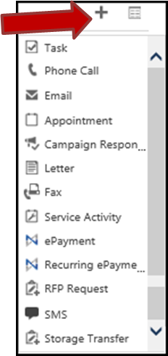**Add Activity Record** button  – When selected, this button offers a dropdown menu of the different Service Activities to add to the move. After selecting what to create from the dropdown, the appropriate form page will display.
   1. Types of Service Activities in the dropdown.
      1. **Task**
      2. **Phone Call**
      3. **Email**
      4. **Appointment**
      5. **Campaign Response**
      6. **Letter**
      7. **Fax**
      8. **Service Activity**
      9. **ePayment**
      10. **Recurring ePayment**
      11. **SMS**
      12. **Storage Transfer**
3. **See the records associated with this view** button  – Selecting this button takes you to the “Open Activity Associated View” page. There you have more capabilities and tools for working with the Service Activities.
4. **Delete** button  – When you mouse over a record Service Activity record it will highlight and the Delete button will be revealed. Selecting this button will delete the Service Activity.

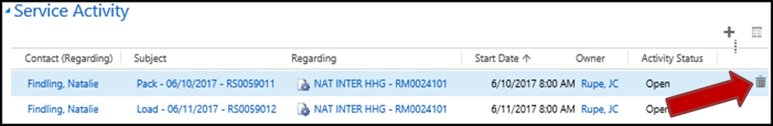

### Billing section

1. The “Billing” section contains billing address and payment information.

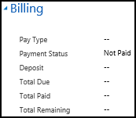

1. Optional fields:
   1. Payment
      1. **Pay Type**
      2. **Payment Status**
      3. **Deposit**
      4. **Total Due**
      5. **Total Paid**
      6. **Total Remaining**

### Government

1. The “Government” section is used for government moves (such as military service member moves).

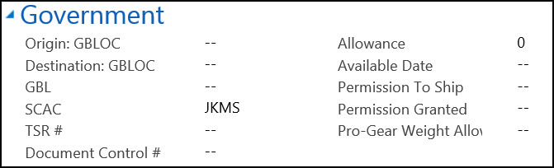

1. Optional fields:
   1. **Origin: GBLOC**
   2. **Destination: GBLOC**
   3. **GBL** – Government Bill of Lading
   4. **SCAC**
   5. **TSR #**
   6. **Document Control #**
   7. **Allowance**
   8. **Available Date**
   9. **Permission To Ship**
   10. **Permission Granted**
   11. **Pro-Gear Weight** **Allowance**

### Entitlements

1. The “Entitlements” section consists of one freeform text field. These are services and limitation that the contract allows for the Client. For military service members, the moving entitlements depend in large measure on the service member’s orders and what is written in them.

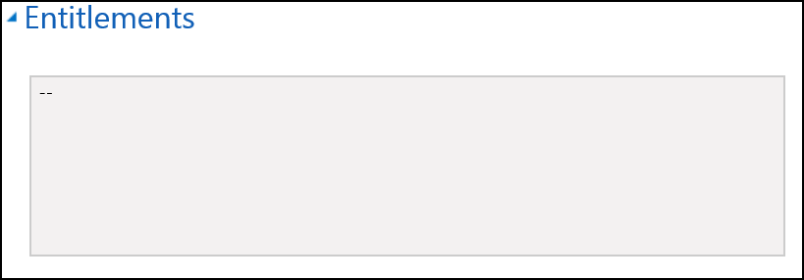

### Administration

1. The “Administration” section lists people assigned to assist in developing the Move.

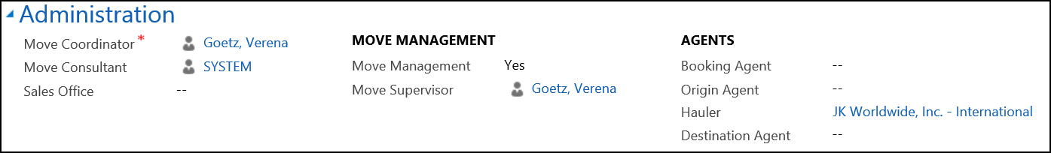

1. Required fields:
   1. **Move** **Coordinator**
2. Optional fields:
   1. **Move Consultant**
   2. **Sales Office**
   3. Move Management subsection
      1. **Move Management**
      2. **Move Supervisor**
   4. Agents subsection
      1. **Booking Agent**
      2. **Origin Agent**
      3. **Hauler**
      4. **Destination Agent**

## Search for a Move

1. The Moves view should be displayed.
2. Perform a Search.
   1. Use the data in the search field that will help locate the desired Move record(s).

## Sort Move View Columns

1. The Moves view should be displayed.
2. Sort Records based on the desired column that will help locate the desired Move record(s).

## Filter Move View Columns

1. The Moves view should be displayed.
2. Filter Records based on the desired column(s) that will help locate the desired Move record(s).

## Set Default View for Moves

1. Navigate to Moves.
2. The default Moves view will be displayed.
3. Set Default View on a Page.
4. The default View should now be set for the Moves page.

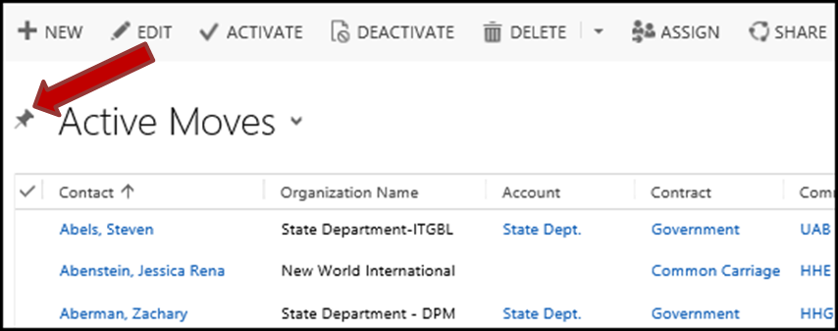

## Create a New Move

1. Navigate to Contacts.
2. Search for a Contact to locate the Contact record for the person being moved.
3. Double click on the desired Contact.
4. The “Contact: Customer” page will be displayed.
5. Expand the “Moves” section.
6. Select the “Add Move Record” button. 

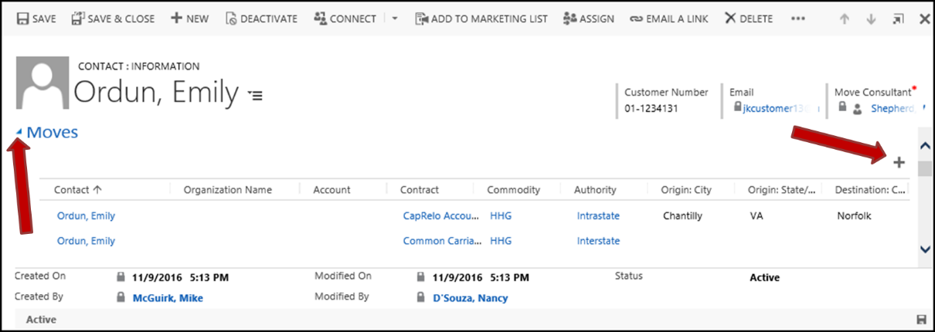

1. The preliminary “Move” data entry page will display.
2. Enter appropriate data into the “Move” page.
   1. Required fields:
      1. **Customer**
      2. **Contract**
      3. **Authority**
      4. **Commodity**
      5. **Service Location**
      6. **Move Coordinator** – The person creating the Move is automatically assigned as the Move Coordinator, but this may be changed now or later.
   2. Business Recommended fields:
      1. **Account**
   3. Optional fields:
      1. **Organization**
      2. **Storage**
      3. **Sales Office**
      4. **Move Consultant**
3. Select the “Save” button.

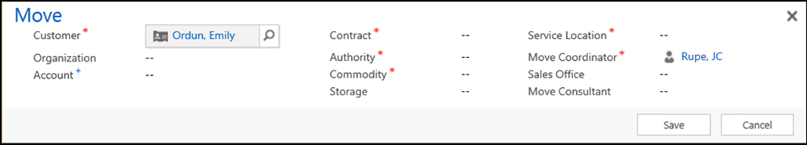

1. The “Move” page will vanish.
2. The “Contact: Customer” page will refresh.
3. The new Move will be displayed in the “Moves” section of the “Contact: Customer” page.
4. Once saved the Move Number will generate and as additional information is available for the move it can be added. See section View and Edit a Move to enter more information about the Move.

## View and Edit a Move

Only Active Moves may be edited.

1. Search for a Move.
2. Double click on the desired Move record.
   1. The “Move” page will open.
3. Select the expansion arrow  to the left of the section(s) to be viewed or edited.
4. Entries are now available for viewing or editing.
5. Select the “Save” button upon completion of editing.

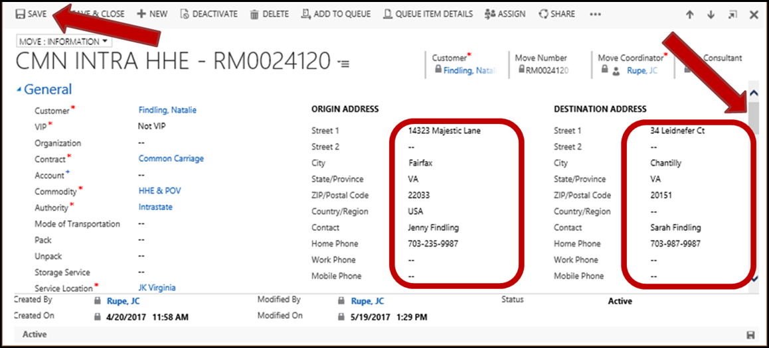

## Assign a Move Coordinator to a Move

1. Navigate to Moves.
2. Double click on the desired Move record.
3. The “Move: Information” page will display.
4. Select the “Assign” button in the upper menu bar.

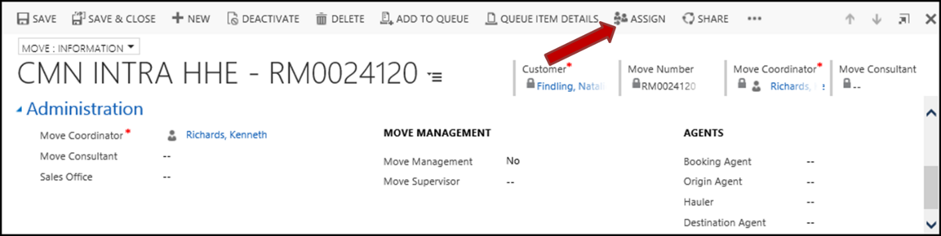

1. The “Assign Move” window will open and display.
   1. Enter an “Assign to” value, this is who the Move is to be assigned.
      1. Options:
         1. Me
         2. User or team
   2. If the “Assign to” equals “User or team”, then enter an appropriate selection into this field.
      1. Select the magnifying glass to locate and select a specific user or team. 
   3. Select the “Assign” button to perform the assignment.

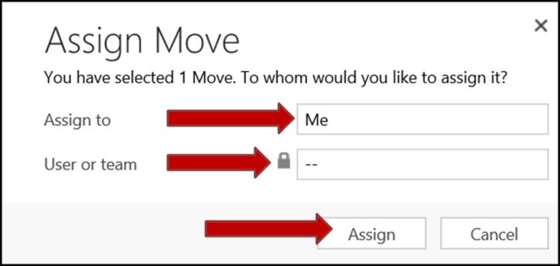

1. The Move Coordinator has now been reassigned.

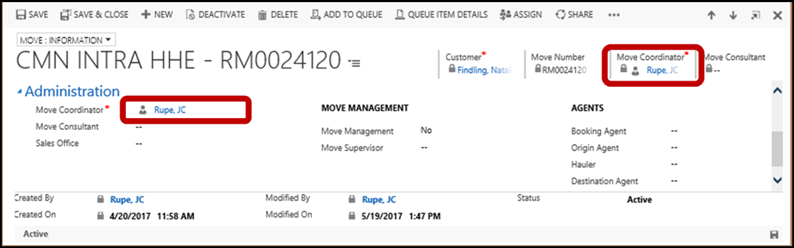

## Deactivate a Move

Deactivating a Move allows you to make a Move inactive, which means it cannot be edited or used. Deactivated Moves may be re activated should the need arise.

1. Navigate to Moves.
2. Your default Moves view page should be displayed.
3. Search for a Move, to locate the Move to be deactivated.
4. [Select Record(s)](#_Selecting_Record(s)) to be deactivated.
5. Select the “Deactivate” button near the top left of the Move view page.



1. A confirmation will display.
   1. The Moves “Status” value may be changed.
      1. Click on the “Status”.

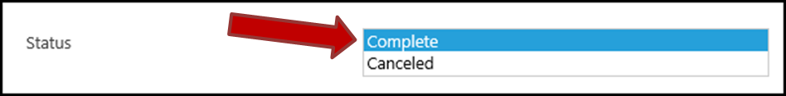

* + 1. Scroll through the options and select a new “Status” value.
       1. Options are:
          1. Complete
          2. Canceled
  1. Select the “Deactivate” button.

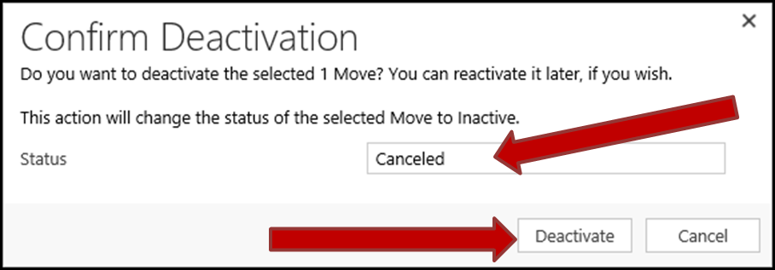

1. The Move is now deactivated.
   1. Any active Service Activities associated with the Move are now closed.

## Activate a Move

Activating a deactivated Move allows you to set a Move back to being Active, which means it may now be edited or used. Note that each desired Service Activity, associated with the Move, must be individually reopened.

See the “JIM - Reactivate a Move - Quick Ref” manual.

## Attach Documents to a Move

See the “JIM – Document Management” manual.

# Service Activities (SA) for Moves

Service activities are services or jobs created for a move.

## Service Activity Main Screen

### Basic Main Screen

1. The main screen of the “Service Activity” window contains 4 panels.
   1. **Service Activity** panel – Which contains basic information about the Service Activity. It includes Resource requirements and Utilization. By default, this panel is the only panel open to view when the “Service Activity” window is opened.
   2. **Addresses** panel – This panel may contain the Origin and Destination information. Including conditions and potential obstacles.
   3. **Details** panel – This panel contains information about estimated packing materials, containers, labor and travel.
   4. **Local Storage** panel – If the goods are to be stored at some point, information about the storage and charges may be entered here.

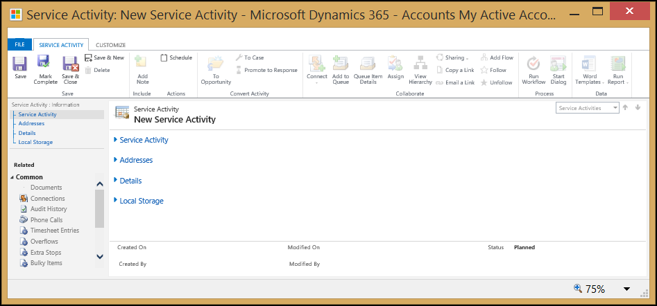

### Service Activity panel

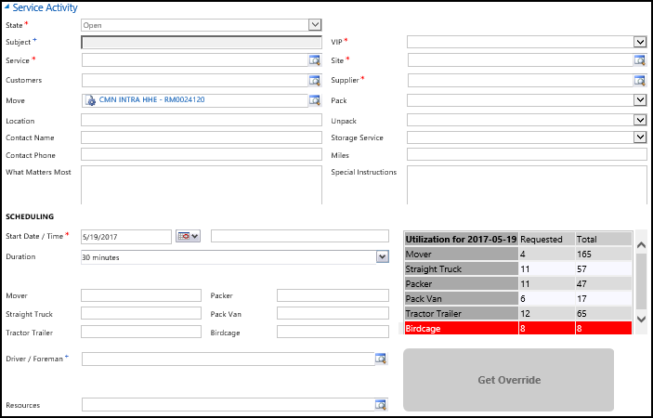

1. Required fields:
   1. **State**
      1. Options are:
         1. Open – default when SA is newly created.
         2. Closed
         3. Canceled
         4. Scheduled
   2. **Service** – Select what Service is to be provided.
   3. **VIP** flag. (VIP or Not VIP)
   4. **Site**
   5. **Supplier**
2. Business Recommended fields:
   1. **Subject**
3. Optional fields:
   1. **Customers**
   2. **Move** – This field contains the Move name and number.
   3. **Location**
   4. **Contact Name**
   5. **Contact Phone**
   6. **Pack**
   7. **Unpack**
   8. **Storage Service**
   9. **Miles**
   10. **What Matters Most**
   11. **Special Instructions**
4. Scheduling subsection
   1. Required fields:
      1. **Scheduled Start Date / Time** – This is the part of the field that only contains the date.
   2. Business Recommended fields:
      1. **Driver / Forman** (in the Scheduling subsection)
   3. Optional fields:
      1. **Scheduled Start Date / Time** – This is the part of the field that only contains the time.
      2. **Duration**
      3. Requested Resources:
         1. **Mover**
         2. **Straight Truck**
         3. **Tractor Trailer**
         4. **Packer**
         5. **Pack Van**
         6. **Birdcage**
      4. **Resources** – This contains the Resources that are actually assigned.

### Addresses panel

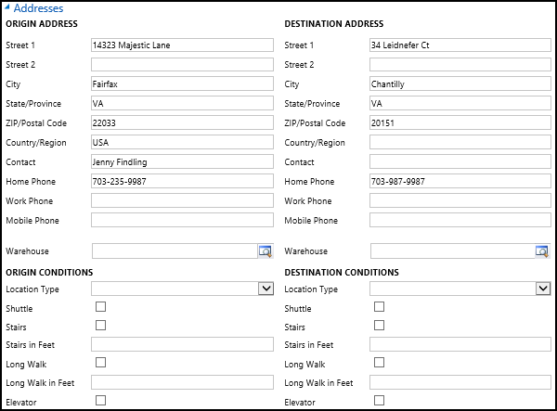

1. Optional fields:
   1. The Origin Address section and the Destination Address section:
      1. The information contained in the two Address sections is initially populated from the parent Move. It may be later edited and changed.
      2. See the Move “General Section” for the fields.
   2. The Origin Conditions section and the Destination Conditions section:
      1. Most of the information contained in the two Conditions sections is initially populated from the parent Move. It may be later edited and changed.
      2. See the Move “General Section” for most of the fields.
      3. Additional fields found just here in the SA:
         1. **Stairs in Feet**
         2. **Long Walk in Feet**

### Details panel

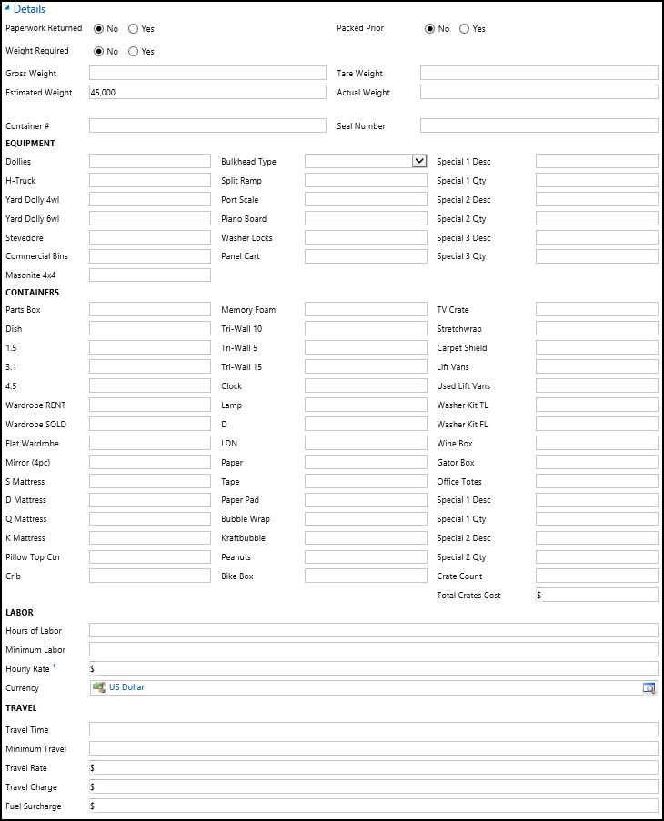

1. Optional fields:
   1. **Paperwork Returned**
   2. **Weight Required**
   3. **Packed Prior**
   4. **Gross Weight**
   5. **Estimated Weight**
   6. **Tare Weight**
   7. **Actual Weight**
   8. **Container #**
   9. **Seal Number**
   10. Equipment subsection
       1. Optional fields:
          1. **Dollies**
          2. **H-Truck**
          3. **Yard Dolly 4wl**
          4. **Yard Dolly 6wl**
          5. **Stevedore**
          6. **Commercial Bins**
          7. **Masonite 4x4**
          8. **Bulkhead**
          9. **Split Ramp**
          10. **Port Scale**
          11. **Piano Board**
          12. **Washer Locks**
          13. **Panel Cart**
          14. **Special 1 Desc**
          15. **Special 1 Qty**
          16. **Special 2 Desc**
          17. **Special 2 Qty**
          18. **Special 3 Desc**
          19. **Special 3 Qty**
   11. Containers
       1. Optional fields:
          1. **Parts Box**
          2. **Dish**
          3. **1.5**
          4. **3.1**
          5. **4.5**
          6. **Wardrobe RENT**
          7. **Wardrobe SOLD**
          8. **Flat Wardrobe**
          9. **Mirror (4pc)**
          10. **S Mattress**
          11. **D Mattress**
          12. **Q Mattress**
          13. **K Mattress**
          14. **Pillow Top Ctn**
          15. **Crib**
          16. **Memory Foam**
          17. **Tri-Wall 10**
          18. **Tri-Wall 5**
          19. **Tri-Wall 15**
          20. **Clock**
          21. **Lamp**
          22. **D**
          23. **LDN**
          24. **Paper**
          25. **Tape**
          26. **Paper Pad**
          27. **Bubble Wrap**
          28. **Kraftbubble**
          29. **Peanuts**
          30. **Bike Box**
          31. **TV Crate**
          32. **Stretchwrap**
          33. **Carpet Shield**
          34. **Lift Vans**
          35. **Used Lift Vans**
          36. **Washer Kit TL**
          37. **Washer Kit FL**
          38. **Wine Box**
          39. **Gator Box**
          40. **Office Totes**
          41. **Special 1 Desc**
          42. **Special 1 Qty**
          43. **Special 2 Desc**
          44. **Special 2 Qty**
          45. **Crate Count**
          46. **Total Crates Cost**
   12. Labor
       1. Business Recommended fields:
          1. **Hourly Rate**
       2. Optional fields:
          1. **Hours of Labor**
          2. **Minimum Labor**
          3. **Currency**
   13. Travel
       1. Optional fields:
          1. **Travel Time**
          2. **Minimum Travel**
          3. **Travel Rate**
          4. **Travel Charge**
          5. **Fuel Surcharge**

### Local Storage panel

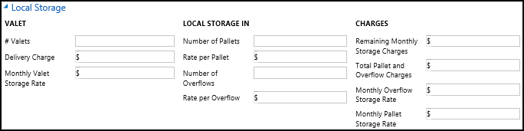

1. Optional fields:
   1. Valet subsection
      1. **# Valets**
      2. **Delivery Charge**
      3. **Monthly Valet Storage Rate**
   2. Local Storage In subsection
      1. **Number of Pallets**
      2. **Rate per Pallet**
      3. **Number of Overflows**
      4. **Rate per Overflow**
   3. Charges subsection
      1. **Remaining Monthly Storage Charges**
      2. **Total Pallet and Overflow Charges**
      3. **Monthly Overflow Storage Rate**
      4. **Monthly Pallet Storage Rate**

## Add New Service Activity to a Move

1. View and Edit a Move.
2. The “Move: Information” page will be displayed.
3. Locate and expand the “Service Activities” panel on the “Move: Information” page.
4. Select the “Add Activity Record” button, in the upper right of the “Service Activities” panel. 

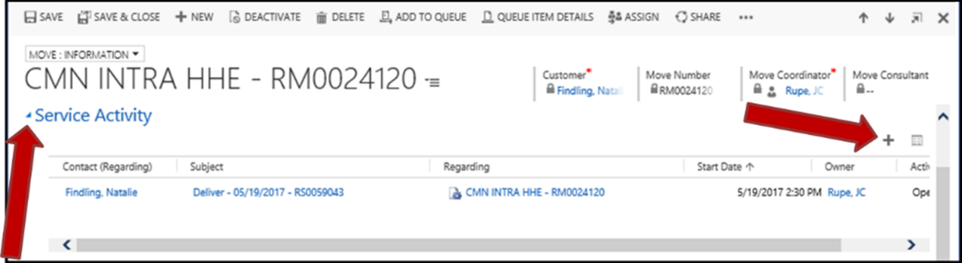

1. The dropdown menu will display.
   1. Select the “Service Activity” option in the dropdown menu.
      1. See Service Activities section for picture of dropdown menu.
2. The “New Service Activity” window will display.
3. Enter valid and appropriate data into the data fields and panels in the “New Service Activity” window.
   1. Scroll down and expand necessary panels.
   2. See section Service Activity Main Screen for more information about the data fields and panels.
4. Select the “Save & Close” button near the top left of the window.

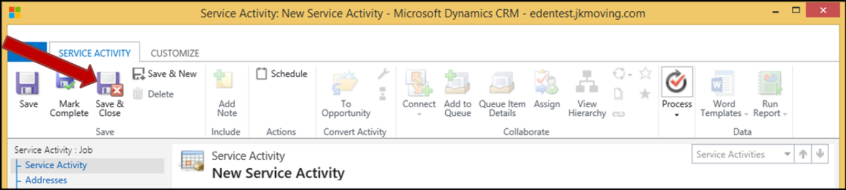

1. Enter Resources, if they are required.
   1. If Resources are required and haven’t been entered, then a message window will display. The message will state what Resources and how many are required.
      1. Select the “OK” button.
2. Select the “Save & Close” button.
3. The “Move: Information” page will refresh.
4. The new Service Activity will be displayed in the “Service Activities” panel.

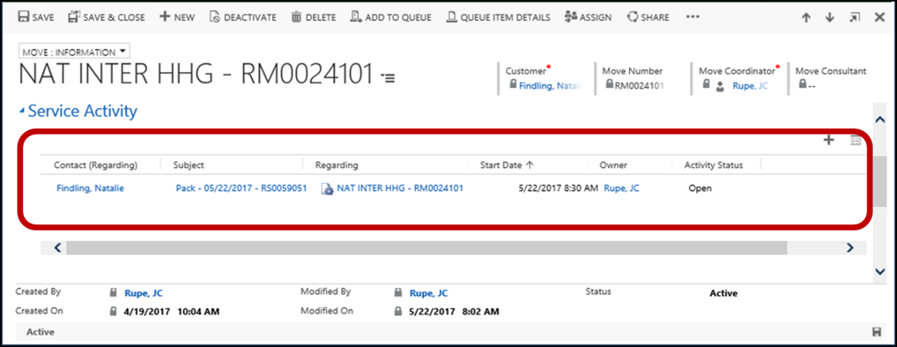

## Reopen a Service Activity

See the “JIM - Reactivate a Move - Quick Ref” manual.

## Assign Default Materials to Service Activity

This section shows the user how to assign default materials based on the entered **Estimated Weight**.

Prerequisite: An Estimated Weight value has been entered for the Move.

1. View and Edit a Move.
2. The “Move: Information” page will be displayed.
3. Locate and expand the “Service Activities” panel on the “Move: Information” page.
4. Double click on the desired Service Activity.

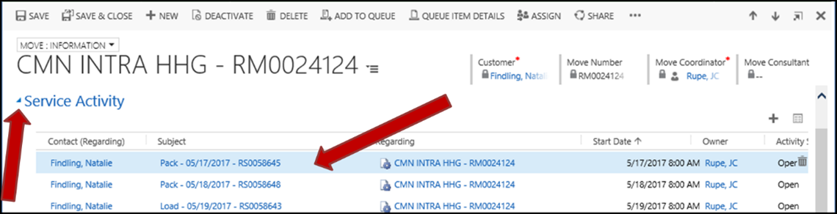

1. The “Service Activity” window will display.
2. Select the “Start Dialog” button in the upper right area of the window.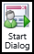
   1. If you don’t see the button, you may try enlarging the window.
   2. The button is part of the “Process” menu items.

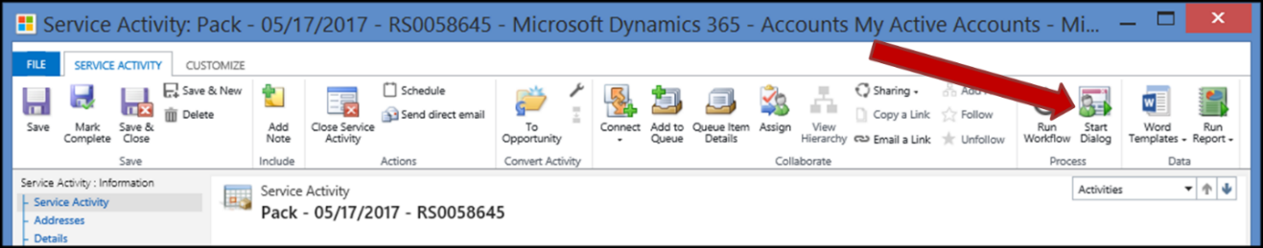

1. The “Look Up Record” window will display.
   1. Select the “Assign Default Materials” process option.
      1. Ensure that there is a check mark on this option.
   2. Select the “Add” button.

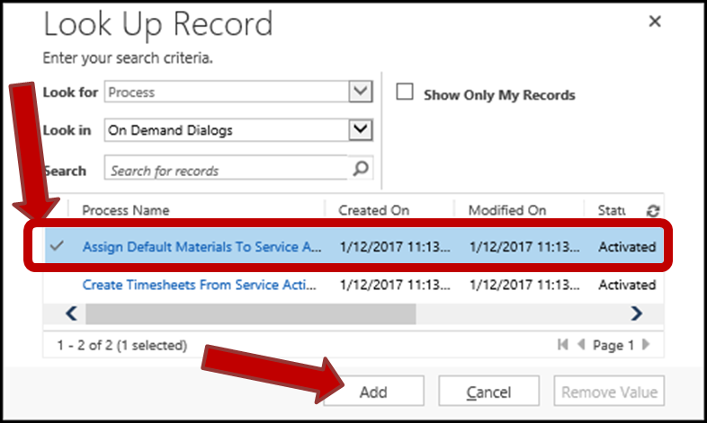

1. The “Assign Default Materials” window will display.
   1. Select how you want existing material counts to be handled.
      1. Options are:
         1. **Replace the current counts** **with the defaults.** – Selecting this option will replace any existing material counts with the default counts.
         2. **Keep the current** **counts.** – Selecting this option will not replace existing material counts and will place default counts that are not already entered.
   2. **NOTE:** There is a panel to the right that contains helpful tips. This panel may be minimized or revealed with the small arrow indicators.  
   3. Enter any comments into the “Comment” field.

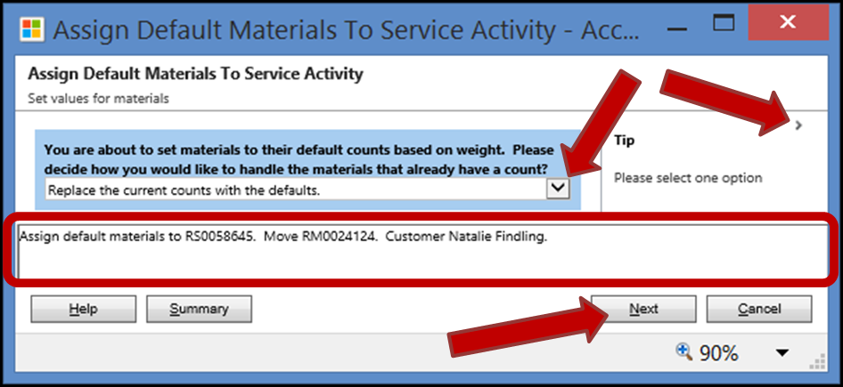

* 1. Select the “Next” button.

1. The “Assign Default Materials” window will refresh.
   1. The message “This is the end of the dialog. Click Finish to close it” will display.
   2. Select the “Finish” button.

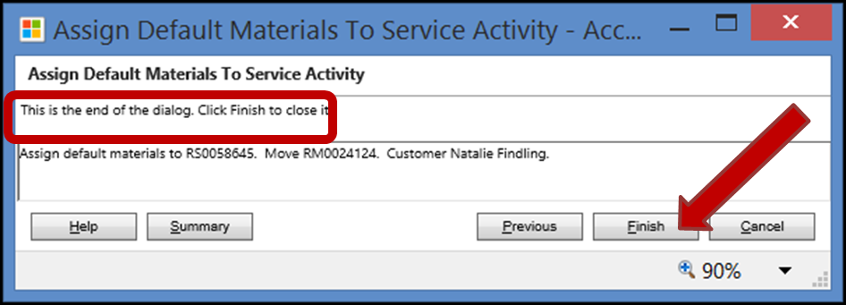

1. The “Assign Default Materials” window will close.
2. The user is returned to the “Service Activity” window.
3. The newly assigned default materials are now saved to the Service Activity.
4. Refresh the “Service Activity” window.
   1. This may be done by selecting the F5 key on your keyboard.
5. Scroll down and expand the “Details” panel.
   1. You will see that default values may have been added to fields in the “Resources” and “Details” panels.
   2. All the fields in the two panels (except the “Site” field) may be changed by assigning default materials.

# Activities

## All Activities Available

1. There are currently 16 Activities available.

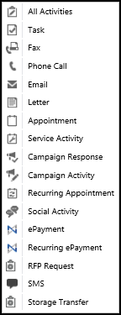

* 1. **All Activities**
  2. **Appointment**
  3. **Campaign Activity**
  4. **Campaign Response**
  5. **Email**
  6. **ePayment**
  7. **Fax**
  8. **Letter**
  9. **Phone** **Call**
  10. **Recurring Appointment**
  11. **Recurring ePayment**
  12. **Service Activity**
  13. **SMS**
  14. **Social Activity**
  15. **Storage Transfer**
  16. **Task**

## Navigate to Contact Activities Page

1. Navigate to Contacts.
2. Search for a Contact, to locate the desired Contact.
3. Open the desired Contact record, by double clicking on it.
4. The “Contact: Customer” page will display.
5. Select the down arrow next to the Contact’s name in the top menu bar.
   1. Select the “Activities” option in the dropdown menu.

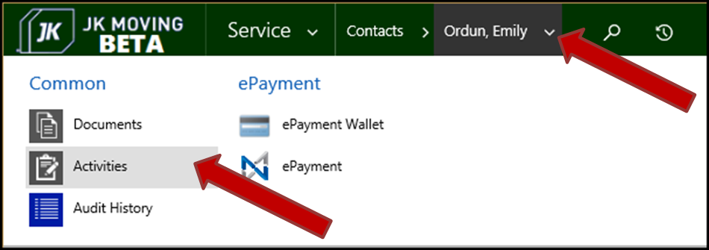

1. The Contact’s “Open Activity Associated View” will display on the “Contact: Customer” page.
   1. Change the “Filter on” value to “All”

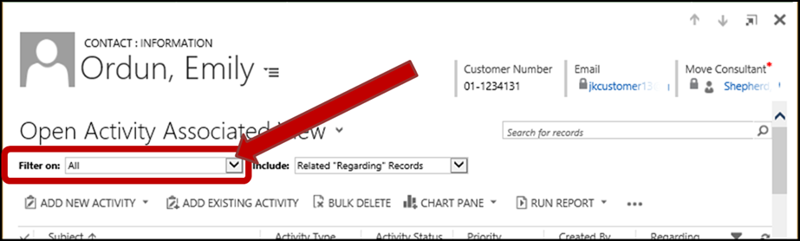

## Navigate to Move Activities Page

1. Navigate to Contacts.
2. Search for a Contact, to locate the desired Contact.
3. Open the desired Contact record, by double clicking on it.
4. Scroll down to and expand the “Moves” panel on the “Contact: Customer” page.
5. Open the desired Move record, by double clicking on it.
6. The “Move: Information” page will display.
7. Select the down arrow next to the Moves’s name in the top menu bar.
   1. Select the “Activities” option in the dropdown menu.

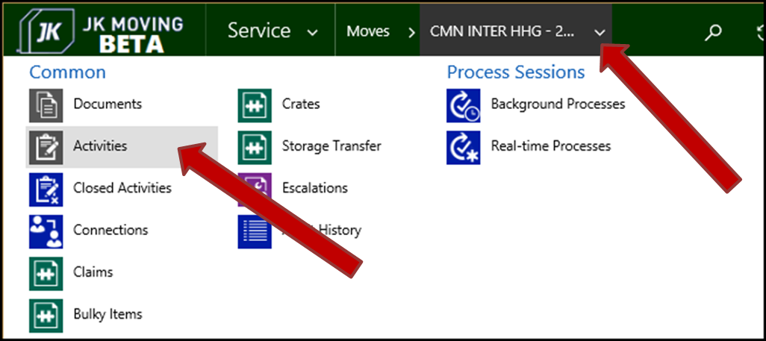

1. The Contact’s “Open Activity Associated View” will display on the “Move: Information” page.

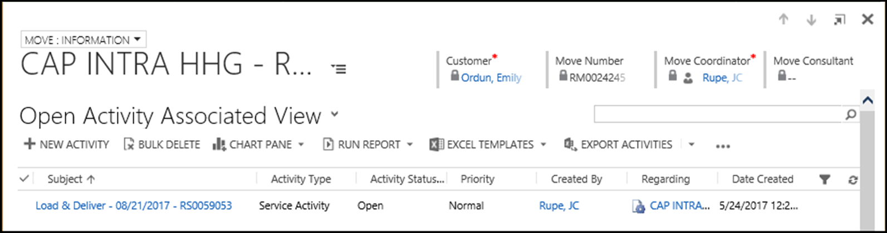

## Add a Contact or Move Activity

1. Navigate to the desired Contact or Move Activities page.
   1. See the steps in either section Navigate to Contact Activities Page or Navigate to Move Activities Page.
2. The appropriate “Information” page will be displayed
3. Select the “New Activity” button.
   1. The “Add New Activity” button on the Contact Activity page.
   2. The “New Activity” button on the Move Activity page (pictured here).

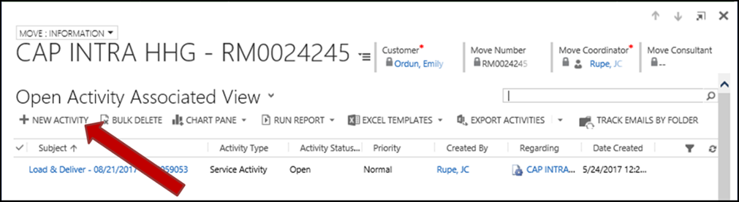

1. The “New Activity” window will display.
   1. Select the desired Activity option in the displayed list.
      1. If needed, use the scroll bar to locate the desired Activity.
   2. Select the “OK” button.

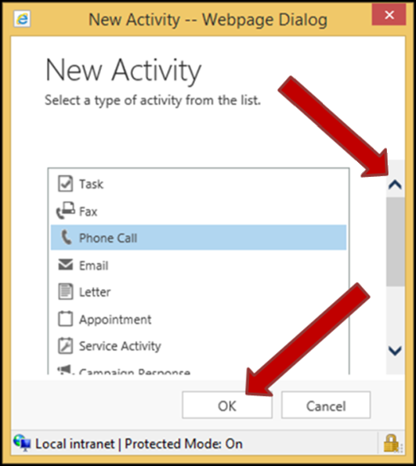

1. The appropriate window or page for adding the desired Activity will display.

## Phone Call Activities

### Add Contact or Move Phone Call

1. Add a Contact or Move Activity, selecting to add a new Phone Call activity.
2. A New Phone Call window will open with the “Phone Call: Information” page displayed.
   1. Note that many of the fields are already populated with the Client and your own information, etc.

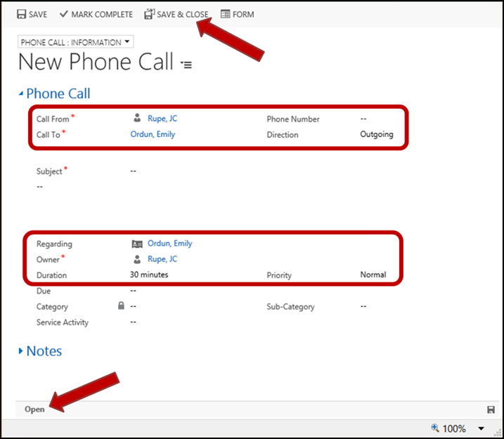

1. Fill out the “New Phone Call” page form with appropriate information.
   1. Required fields:
      1. **Call From** – This is the name of the account, contact, lead or user making the call.
      2. **Call To** – This is the name of the account, contact, lead or user recipients of the phone call.
      3. **Subject** – This is a brief description about the objective or primary topic of the phone call.
      4. **Text Body** – This text field isn’t labeled. It is located just below the Subject and is for a detailed description of the phone call.
      5. **Owner** – Enter the user or team who is assigned to manage the record. This field is updated every time the record is assigned to a different user.
   2. Optional Fields:
      1. **Phone Number** – This is the Contact’s phone number.
      2. **Direction** – Indicates the direction of the phone call.
         1. Options are:
            1. Outgoing – This indicates that the Contact is the recipient of the phone call.

True – This used to be the default value and it represents Outgoing.

* + - * 1. Incoming – This indicates that the Contact is the person who initiated the phone call.

Selecting this option will switch the “Call From” and “Call To” fields to the appropriate values.

* + 1. **Regarding** – The account, contact, move and etc. with which the phone call activity is associated.
    2. **Duration** – The length of the phone call in minutes. The Duration is used in reporting.
    3. **Priority** – Used so that preferred customers or critical issues are handled quickly.
       1. Options are:
          1. Low
          2. Normal
          3. High
    4. **Due** – The expected Due date and time.
    5. **Category** – This identifies the phone call type, such as lead gathering or customer follow-up, to tie the phone call to a business group or function.
    6. **Sub-Category** – Used to further categorize the phone call.
    7. **Service Activity** – If any, the specific Service Activity that is associated with this phone call.
  1. **Notes** panel – With a new phone call, this panel doesn’t display any records. The intent of this panel is to display any Notes that are added later, after the phone call Activity is already created.
  2. **Call Status** – The status of the phone call is shown in the lower left corner of the page.
     1. Possible values:
        1. Open
        2. Completed

1. Select the “Save & Close” button in the upper menu bar.
2. The “New Phone Call” window will close.
3. The new Phone Call Activity is now created and saved.

### Add Notes to Phone Call Activity

1. Open the desired Phone Call Activity.
   1. See the steps in either View Contact Phone Call or View Move Phone Call.
2. The “Phone Call: Information” page should be displayed.
3. Locate and open the “Notes” section of the documented Phone Call.
4. Select the “Notes” field.
   1. The field will open up and allow entry of text.

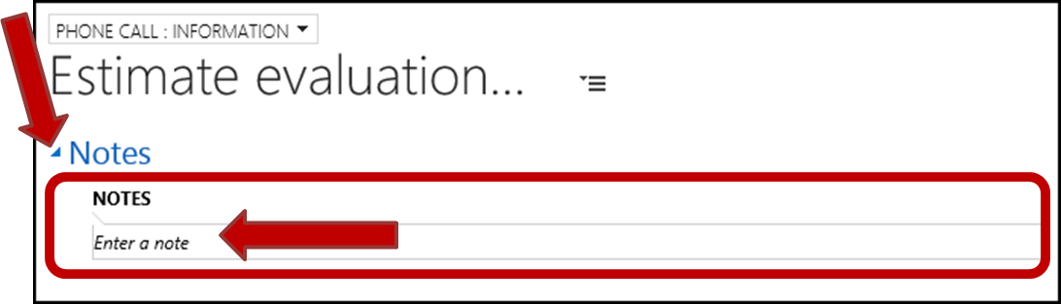

1. Enter the desired Notes information.
   1. Enter a “Title” for the Note.
   2. Enter a Note body.
   3. Scroll down to reveal the buttons.
   4. Use the “Attach” button to attach documents to the Note.
   5. Select the “Done” button when the Note is completed.

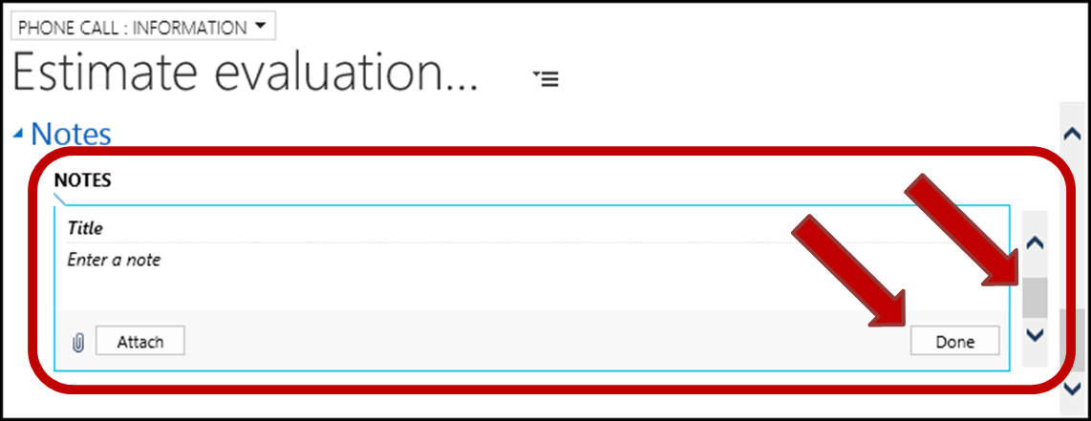

1. The newly added Note now appears in the Note display area.

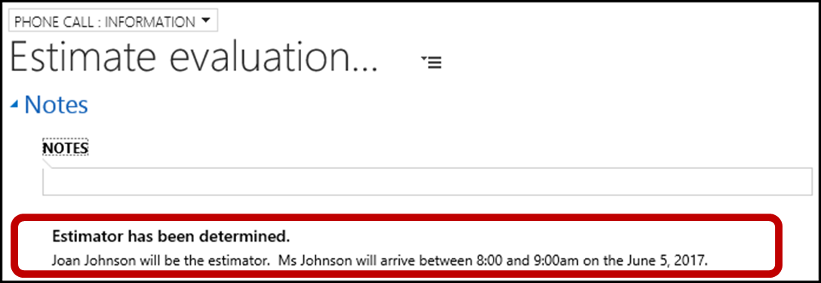

1. The Note is now saved to the Phone Call Activity.

### View Contact Phone Call

1. Navigate to Contact Activities Page, for the desired Contact.
2. The “Open Activity Associated View” will display on the “Contact: Customer” page.
3. Filter Records on the “Activity Type” column for Phone Call activities.
4. Locate the desired Phone Call.
5. Open the Phone Call, by double clicking on the desired Phone Call.
6. The Phone Call will open in the “Phone Call: Information” page.

### View Move Phone Call

1. Navigate to Move Activities Page, for the desired Move.
2. The “Open Activity Associated View” will display on the “Move: Information” page.
3. Filter Records on the “Activity Type” column for Phone Call activities.
4. Locate the desired Phone Call.
5. Open the Phone Call, by double clicking on the desired Phone Call.
6. The Phone Call will open in the “Phone Call: Information” page.

## Email Activities

### Add Contact Email

1. Navigate to Contact Activities Page, for the desired Contact.
2. The “Contact: Customer” page will be displayed.
3. Select the down arrow on the “Add New Activity” button.

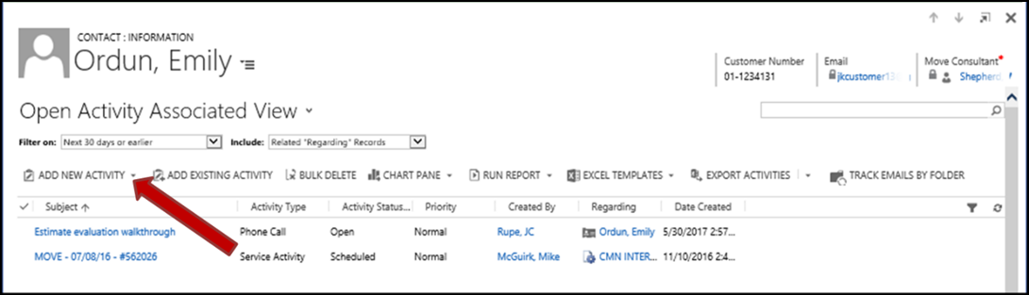

1. The Activities menu dropdown will display.
   1. Select the “Email” option in the dropdown menu that displays.

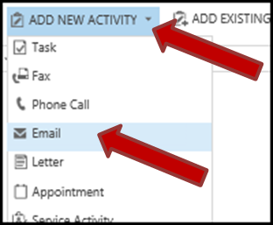

1. A new window will open for the New Email with the “Email: Information” page displayed.
2. Continue on to the steps in section Complete the Add New Email.

### Add Move Email

1. Navigate to the desired Move and open the “New Email” form.
   1. Add a Contact or Move Activity.
      1. The Activity to be added is the “Email” option.
2. A new window will open for the New Email with the “Email: Information” page displayed.
3. Continue on to the steps in section Complete the Add New Email.

### Complete the Add New Email

This section follows after performing the steps in either section Add Contact Email or section Add Move Email. This section is used as part of both of those processes.

1. A New Email window should be open with the “Email: Information” page displayed.
   1. **NOTE:** If the “Email: Wizard” page is displayed, switch to the “Email: Information” page.
   2. Note that many of the fields are already populated with the Client and your own information, etc.

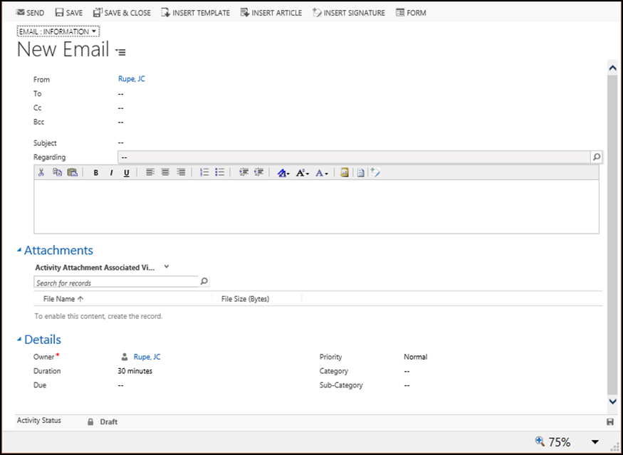

1. Fill out the “New Email” page form with appropriate information.
   1. Optional fields:
      1. **From** – The sender of the email.
      2. **To** – This is the name of the account, contact, lead, queue or user recipients of the email.
      3. **CC** – Enter anyone that should be visibly copied in the email.
      4. **BCC** – Enter included recipients that are not to be displayed to the other recipients.
      5. **Subject** – This is a brief description about the objective or primary topic of the email.
      6. **Regarding** – The account, contact, move and etc. with which the email activity is associated.
      7. **Text Body** – This field is for entering the detailed content of the email.
   2. **Attachments** panel
      1. Attachments must be made after the email is created and saved.
   3. **Details** panel
      1. Required fields:
         1. **Owner** – Enter the user or team who is assigned to manage the record. This field is updated every time the record is assigned to a different user.
      2. Optional fields:
         1. **Duration** – The number of minutes spend creating and sending the email. The Duration is used in reporting.
         2. **Priority** – Used so that preferred customers or critical issues are handled quickly.
            1. Options are:

Low

Normal – This is the Default value.

High

* + - 1. **Due** – The expected Due date and time.
      2. **Category** – This identifies the email type, such as lead outreach, customer follow-up, or service alert, to tie the email to a business group or function.
      3. **Sub-Category** – Used to further categorize the email.

1. Select the “Save & Close” button in the upper menu bar.

|  |
| --- |
| **Important:**  **Don’t attempt to send the email at this time.**  Before you are able to actually send your email, you must first Save and Close the email you have created. Then open the email and send it. This is due to the nature of the CRM tool. |

1. The Email window will close.
2. The “Open Activity Associated View” for the Move will redisplay.
3. The new Email Activity is now created and saved.
   1. **Note:** The email is not yet sent.
4. Locate the newly created email draft.
5. Open the email.
   1. Double click on it.
6. The draft email will open.
   1. The “State” is “Open”.
   2. The “Status” is “Pending”.
7. Make any updates or additions to the email
   1. Include Email Attachments, at this time.
   2. Make any other desired changes to the email.
8. Select the “Save” button, to save the changes to the email.
9. Select the “Send button” in the upper menu bar.
   1. The Email window will close.
10. The Moves main page will redisplay.
    1. Navigate to the Moves **All Activities** page.
11. Open the email.
    1. The email “Activity Status” will change to “Pending Send”.

### Include Email Attachments

Attachments must be made after the email is saved and closed. These steps are performed after the email has been created and saved, but has not been sent.

1. If the (unsent) email is not already open, then locate and open it.
   1. See the steps in either section View Contact Email or section View Move Email.
2. The “Email: Information” page should be displayed.
3. Scroll down to the “Attachments” panel.
4. Select the “Add Attachment Record” button. 

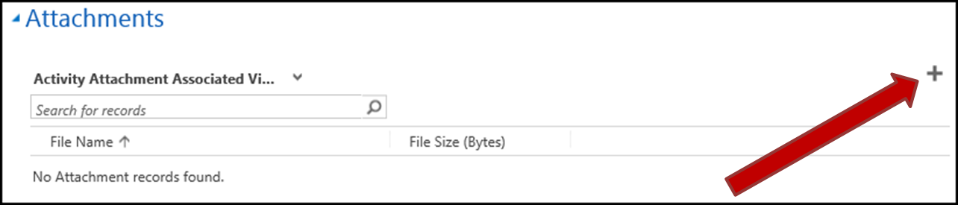

1. The “Manage Attachment” window will open.
2. Select the “Browse” button.

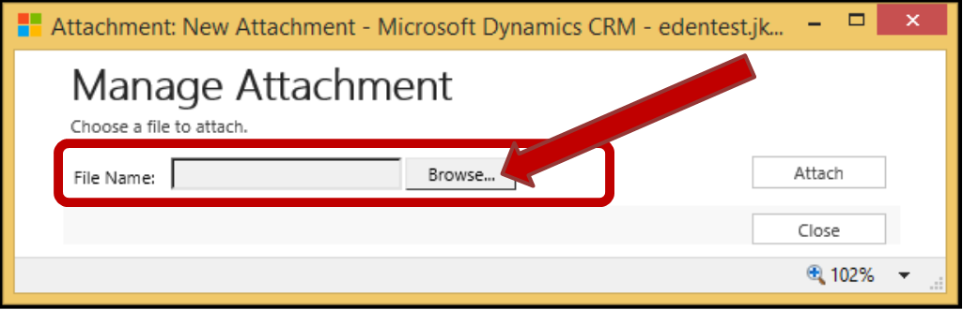

1. Locate and select the file to be attached.
   1. The “File Name” field will be populated once the file was selected.
   2. Select the “Attach” button.

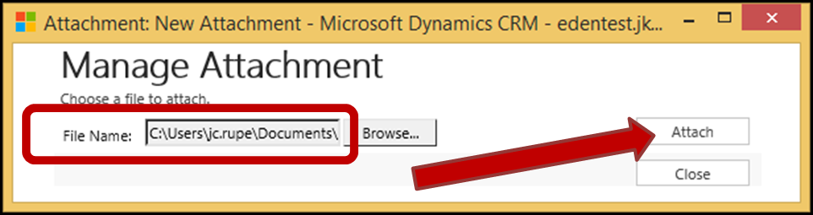

1. The “Manage Attachment” window will redisplay, showing the Attachment.
2. Select the “Close” button.
3. The Attachment(s) are now included in the Email.

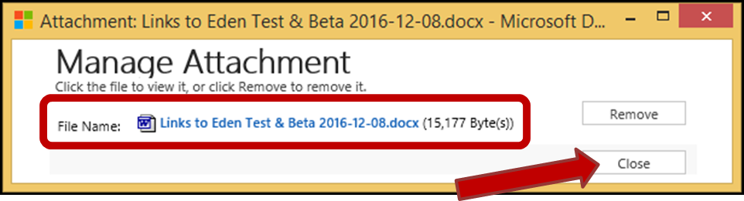

1. The “Email: Information” page will refresh.
2. The added Attachment will appear in the “Attachments” section.

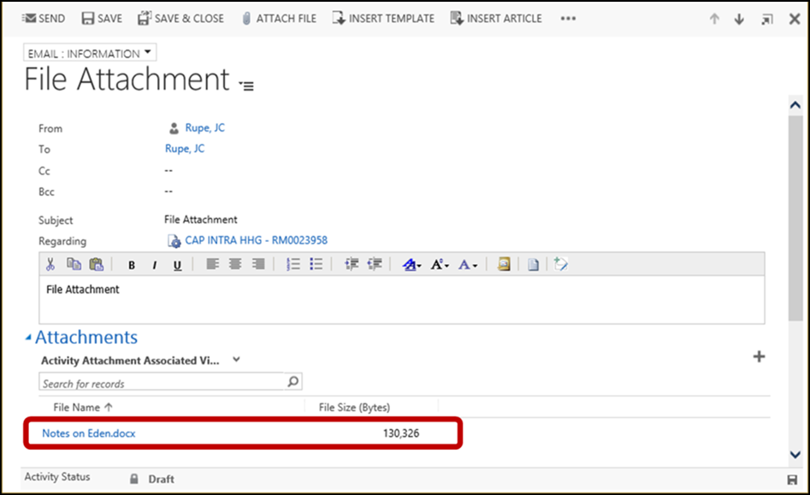

### View Contact Email

1. Navigate to Contact Activities Page
2. The “Open Activity Associated View” will display on the “Contact: Customer” page.
3. Filter Records on the “Activity Type” column for email activities.
4. Locate the desired Email.
5. Open the email, by double clicking on the desired email.
6. The Email will open in the “Email: Information” page.

### View Move Email

1. Navigate to Move Activities Page.
2. The “Open Activity Associated View” will display on the “Move: Information” page.
3. Filter Records on the “Activity Type” column for email activities.
4. Locate the desired Email.
5. Open the email, by double clicking on the desired email.
6. The Email will open in the “Email: Information” page.

## Reply or Forward Email

### Prepare Reply/Forward Email

1. If the desired email is not already open, then navigate to the “Email” page in JIM.
   1. See either section View Contact Email or section View Move Email in this document.
2. The “Email” page will be displayed.
3. Select an action from the menu bar near the top of the page.
   1. Actions:
      1. **Reply** – Use this to reply to the sender of the email.
      2. **Reply All** – Use this to reply to the sender and everyone in the included in the email.
      3. **Forward** – Use this to forward the email to someone else.
   2. For this example, select the “Forward” option.

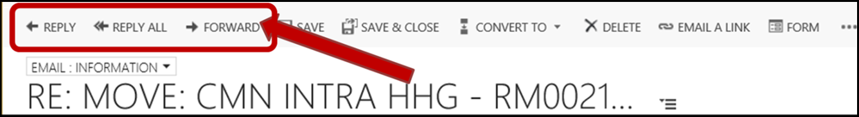

1. The “Email” page will refresh ready for entering text.
2. Include Email Attachments, at this time.
3. Enter appropriate information.
   1. See section Complete the Add New Email to see information about the fields.
4. Select the “Save” button, to save the changes to the email.
5. Select the “Send” button from the menu bar near the top of the page.
   1. The “Email” page will refresh.
   2. **Be patient, i**t can take seconds to many minutes for the email to be processed and sent.
   3. An informational message should appear “This message has not yet been submitted for delivery. For more information, see help.”
      1. This message appears with the email until the email completes processing and is finally sent.
   4. If the system detects harmful content, you may receive an informational message “The email below might contain script or content that is potentially harmful and has been blocked. See the full content.”.
      1. Along with this message a message window may pop up.
         1. Select the “OK” button.
         2. The window may reappear once more.
         3. Again, select the “OK” button.
      2. **Note:** The message will be sent, with anything considered harmful removed.

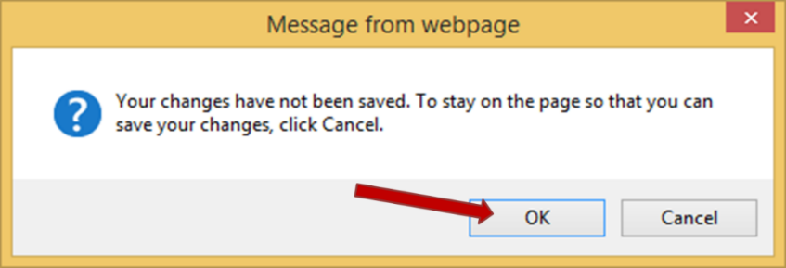

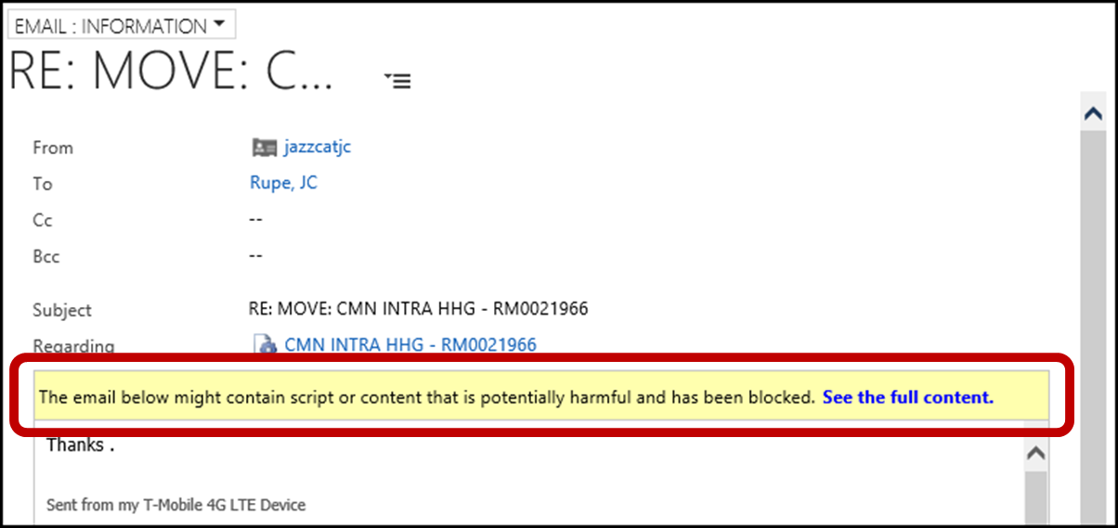

* 1. A message window may appear asking if you want to send the email.
     1. Place a check mark in the box for “Remember my answer”.
     2. Select the “Yes” button.

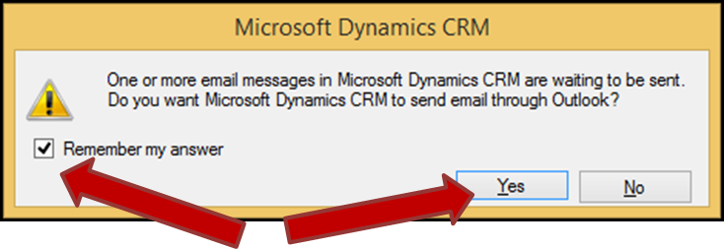

## Email Management using Outlook Set Regarding Tracking

See the “JIM – Outlook Set Regarding - Email Management” manual.

# Print Overflow Labels

## Navigate to Overflows

1. Select the “Service” Work Area, from the Main menu.
2. Locate and select the “Overflows” Area under the “Extensions” column.

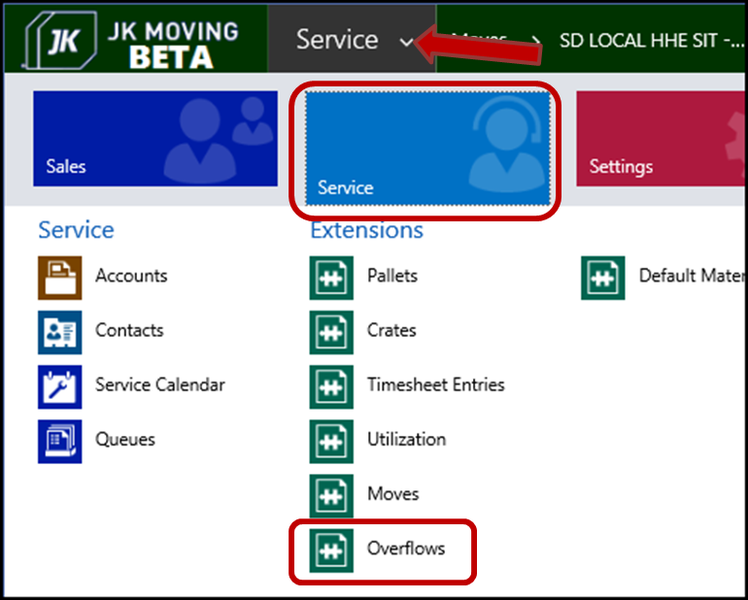

1. The default Overflows page will display.

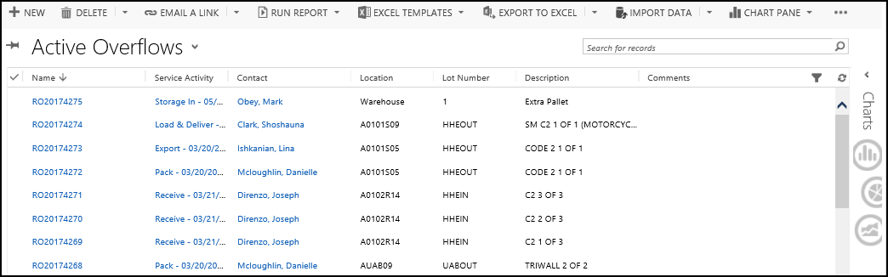

## Create New Overflow

1. Navigate to Overflows.
2. Select the “New” button in the upper left of the page.

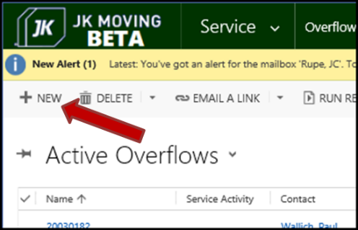

1. The “New Overflow” page will display.
   1. Enter valid information.
      1. **Overflow ID** – This field will be populated by the system when the New Overflow is created.
      2. Required:
         1. **Description**
         2. **Location**
         3. **Customer**
      3. Optional:
         1. **Lot Number**
         2. **Last Handled By**
         3. **Service Activity**
2. Select the “Save” button in the upper left of the page.
   1. The new overflow will redisplay with its “Overflow ID” assigned.

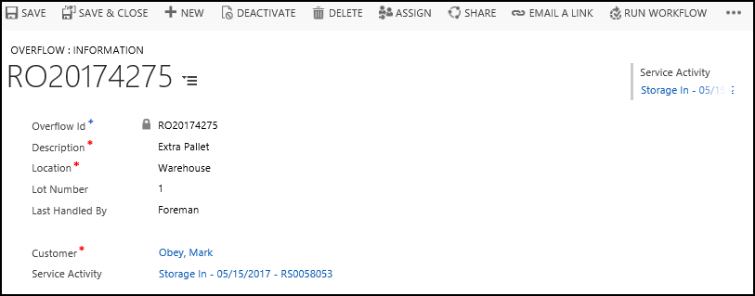

## Print an Overflow

1. Navigate to Overflows.
2. Locate the Overflow record(s), using Search & Filter Record Views.
3. Select the desired record(s).

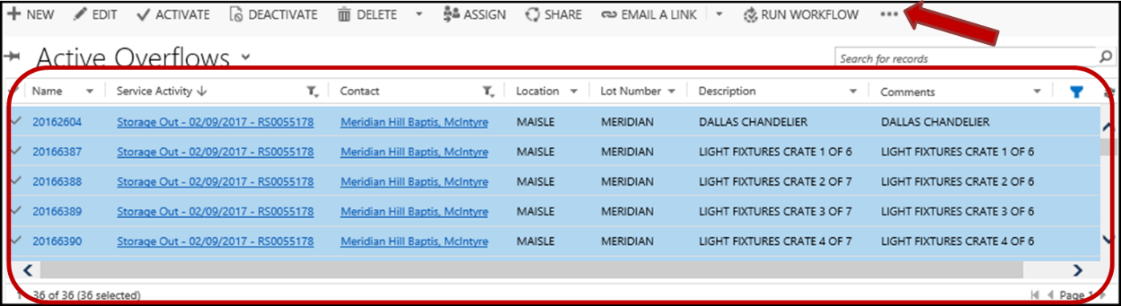

1. Select the “More Commands” button. 
   1. Select the “Run Report” option, in the dropdown menu.
   2. Select the “Overflow Label” option, in the dropdown submenu.
2. The “Select Records” window may display.
   1. Choose which Overflow labels to include in the report.
      1. Options:
         1. **All applicable records**
         2. **The selected records**
         3. **All records on all pages in the current view**
   2. Select the “Run Report” button.
3. The “Overflow” Label Report window will open and display.
4. Print the Label(s), by selecting the “Print” button. 
   1. Close the “Overflow” Label Report window, by selecting the X in the upper right.

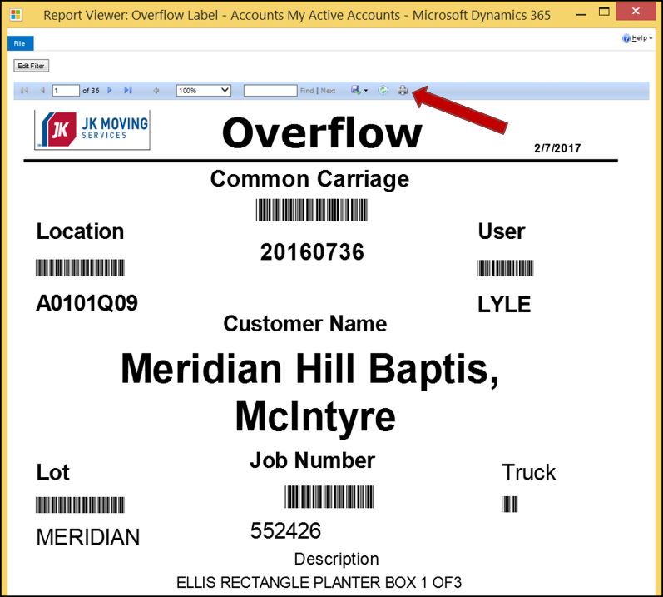

# Pallets

## Navigate to Pallets

1. Select the “Service” Work Area, from the Main menu.
2. Locate and select the “Pallets” Area under the “Extensions” column.

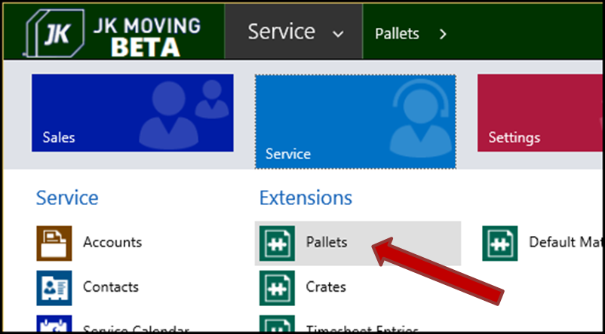

1. The default Pallets View page will appear.

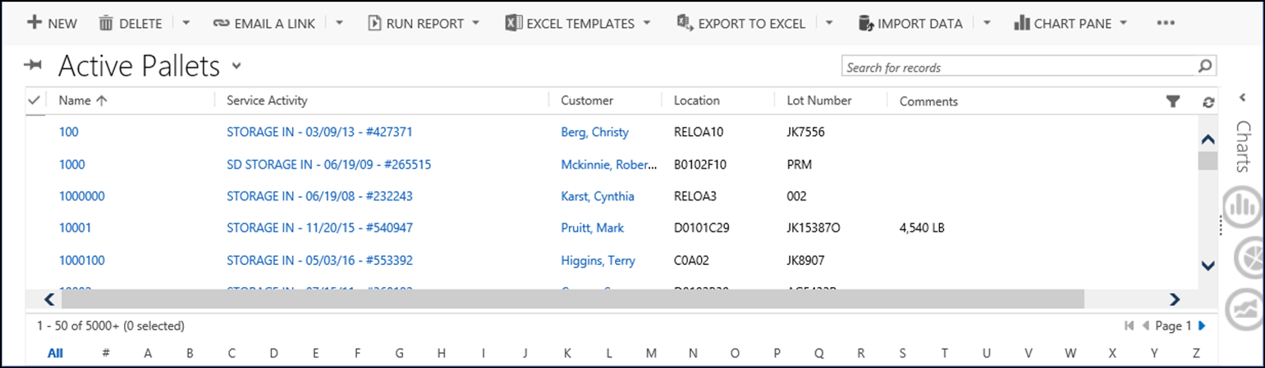

## Add a Pallet

1. Navigate to Pallets.
2. Select the “New” button in the upper menu.

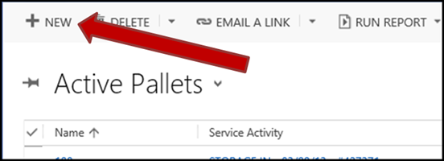

1. The “New Pallet” view will display on the “Pallet: Information” page.
2. Enter valid data into the fields.
   1. **Pallet ID**
   2. **Location**
   3. **Lot Number**
   4. **Last Handled By**
   5. **Status**
      1. Options are:
         1. Empty and Out on Job
         2. Full and In Storage
         3. Full and Out on Job
         4. Empty and In Storage
   6. **Customer**
   7. **Service Activity**
   8. **Comments**
3. Select the “Save” button
4. The “Pallet” is now created.

